Acad Connect

A Project Report
Presented to
The Faculty of the College of
Engineering
San Jose State University
In Partial Fulfillment
Of the Requirements for the Degree
Master of Science in Software Engineering
By
Ankit Anand, Adityaraj Kaushik, Rishabh Malviya
May 2026

Copyright © 2026
Ankit Anand, Adityaraj Kaushik, Rishabh Malviya
ALL RIGHTS RESERVED

APPROVED

Ishie Eswar, Project Advisor
Dan Harkey, Director, MS Software Engineering
Jorjeta Jetcheva, Department Chair

ABSTRACT

Acad Connect
By Ankit Anand, Adityaraj Kaushik, Rishabh Malviya

The process of finding a suitable faculty advisor and finalizing projects is often chaotic and time-consuming. Students face difficulties in identifying faculty members whose expertise aligns with their interests, while faculty struggle to manage numerous requests and track their supervision capacity. This lack of organization leads to confusion, inefficiency, and repeated back-and-forth communication. Traditionally, this process has been handled manually, with students reaching out individually to faculty and forming groups in an unstructured way. This results in delays, missed opportunities, and significant administrative overhead for both sides. The absence of a centralized system makes it harder to document project details, and ensure fair allocation of supervision responsibilities. To address these challenges, we propose the development of a Faculty–Student Project Collaboration Platform with distinct interfaces for students and faculty. The platform enables structured communication, transparent project matching, and systematic project tracking. With integrated AI features such as faculty recommendations, snippet feedback, and project insights, the system further enhances efficiency. Compared to traditional methods, this solution minimizes chaos, saves time, and ensures a smoother academic collaboration experience for both students and faculty.
Acknowledgments
The authors are deeply indebted to professor Eshie Eswar

Table of Contents
Chapter 1. Project Overview 1
Introduction 1
Proposed Areas of Study and Academic Contribution 1
Motivation and Objectives 1
Current State of the Art 1
Limitations of Existing Systems 1
Overview of the Proposed System (Acad Connect) 1
Chapter 2. Project Architecture 2
Introduction 2
System Overview 2
High Level Architecture Diagram 2
Architecture Subsystems 2
Client Layer (Student & Faculty Interfaces) 2
API Gateway Layer 2
Microservices Layer 2
Data Layer 2
External Services 2
Microservices Description 2
User Service 2
Project Service 2
Notification Service 2
Recommendation Service 2
Snippet Feedback Service 2
System Data Overflow 2
Security and Authentication Model 2
Scalability Considerations 2
Chapter 3. Technology Descriptions 3
Client Technologies 4
React.js 4
UI Component Libraries 4
WebSocket Client Integration 4
Middle-Tier Technologies 4
Node.js Backend Services 4
Python AI Services (FastAPI/Flask) 4
Kafka Messaging System 4
API Gateway (NGINX) 4
Data-Tier Technologies 4
PostgreSQL Relational Database 4
MongoDB NoSQL Database 4
Database Indexing and Optimization 4
AI and NLP Technologies 4
TF-IDF Based Recommendation Engine 4
NLP Processing for Snippet Analysis 4
Chatbot Integration 4
Containerization and Infrastructure 4
Docker 4
CI/CD Pipeline 4
Cloud Deployment Infrastructure 4
Chapter 4. Project Design 5
Introduction 5
System Workflow 5
Student Workflow 5
Faculty Workflow 5
Admin Workflow 5
UML Design Diagrams 5
System Use Case Diagram 5
Class Diagrams 5
Sequence Diagrams 5
Client Design 5
Middle-Tier Design 6
Include UML diagrams describe your middle-tier components. 6
REST API Design 6
Data-Tier Design 6
AI Recommendation System Design 6
Chapter 5. Project Implementation 7
Introduction 7
Client Implementation 7
Student Interface Implementation 7
Faculty Interface Implementation 7
Admin Interface Implementation 7
Middle-Tier Implementation 7
User Service Implementation 7
Project Service Implementation 7
5Notification Service Implementation 7
Data-Tier Implementation 8
Database Setup 8
Data Migration and Seeding 8
Query Optimization 8
AI Service Implementation 8
Faculty Recommendation Engine 8
Snippet Feedback Engine 8
API Endpoints Overview 8
Chapter 6. Testing and Verification 9
Testing Strategy 9
Unit Testing 9
Integration Testing 9
System Testing 9
User Acceptance Testing 9
Security Testing 9
Test Results and Analysis 9
Chapter 7. Performance and Benchmarks 10
Performance Objectives 10
System Load Testing 10
Stress Testing 10
Scalability Evaluation 10
Response Time Analysis 10
Benchmark Results 10
Chapter 8. Deployment, Operations, Maintenance 11
Deployment Architecture 11
Containerization Strategy 11
Continuous Integration and Continuous Deployment 11
Monitoring and Logging 11
System Maintenance Plan 11
Backup and Recovery Strategy 11
Chapter 9. Summary, Conclusions, and Recommendations 12
Summary 12
Conclusions 12
Recommendations for Further Research 12
Glossary 13
References 14
Appendices 15
Appendix A. 15

List of Figures

Figure 2.1 9
Figure 2.2 Entity Relationship Diagram (ERD) for Acad Connect database schema 13
Figure 2.3 Admin Class Diagram showing Admin, Audit, Student, and Dashboard entities 14
Figure 2.4 Eligibility Management UI showing student status and admin actions 15
Figure 2.5 Audit Logs UI displaying timestamped admin actions and system events 19
Figure 4.1 Acad Connect System Architecture serving as the high-level use case reference 36
Figure 4.2 Faculty-side UML Class Diagram 37
Figure 4.3 Student-side UML Class Diagram 38
Figure 4.4 Admin-side UML Class Diagram 39
Figure 4.5 Sequence Diagram -- Student Registration and Profile Setup 40
Figure 4.6 Sequence Diagram -- Project Snippet Submission and Feedback 41
Figure 4.7 Sequence Diagram -- Faculty Recommendation Request 42
Figure 4.8 Sequence Diagram -- Mentorship Request Submission 44
Figure 4.9 Sequence Diagram -- Faculty Accept/Reject Request 44
Figure 4.10 Sequence Diagram -- Notification Delivery 45
Figure 4.11 Sequence Diagram -- Project Progress Milestone Update 46
Figure 4.12 Sequence Diagram -- Admin Eligibility Update 46
Figure 4.13 Sequence Diagram -- Audit Log Recording 47
Figure 4.14 Faculty Dashboard UI 48
Figure 4.15 Faculty Request Management UI 48
Figure 4.16 Faculty Profile Management UI 49
Figure 4.17 Faculty Project Tracking UI 49
Figure 4.18 Faculty Capacity Management UI 50
Figure 4.19 Student Dashboard UI 50
Figure 4.20 Student Faculty Discovery UI 51
Figure 4.21 Student Snippet Submission UI 52
Figure 4.22 Student Request Tracking UI 53
Figure 4.23 Student Project Progress UI 54
Figure 4.24 Admin Dashboard UI 55
Figure 4.25 Admin Eligibility Management UI 55
Figure 4.26 Admin Audit Logs UI 56
Figure 4.27 Entity Relationship Diagram (ERD) -- PostgreSQL Schema 58

Project Overview

Introduction:
Academic collaboration between students and faculty advisors is a cornerstone of graduate education, yet the process of establishing these partnerships remains largely informal and fragmented at most institutions. Students seeking project supervisors must independently identify faculty whose research interests align with their own, navigate unclear availability signals, and manage communication across disparate channels. Faculty, in turn, face mounting administrative overhead as they handle unsolicited requests, evaluate incomplete proposals, and manually track their supervision capacity. The absence of a unified digital infrastructure amplifies these inefficiencies, leading to missed opportunities, inequitable advisor distribution, and delays in project initiation.
Acad Connect is a web-based Faculty-Student Project Collaboration Platform designed to address these challenges through a combination of structured workflow management and AI-driven intelligence. Built on a microservices architecture and deployed via containerized services, the platform centralizes profile management, project request handling, progress tracking, and real-time notifications into a single cohesive environment. By layering natural language processing (NLP) capabilities on top of this operational foundation, Acad Connect further enables intelligent faculty recommendation, project snippet feedback, and a conversational chatbot assistant — transforming a historically manual and opaque process into a transparent, data-informed collaboration experience.

Proposed Areas of Study and Academic Contribution:
Acad Connect spans two complementary areas of academic inquiry. The first is AI-driven recommendation and natural language processing, with a specific focus on applying embedding-based semantic matching and TF-IDF similarity models to the domain of advisor-student alignment. Unlike traditional keyword-based search, the platform's recommendation engine analyzes free-text project snippets to surface faculty whose expertise is semantically related to a student's stated interests — a contribution to the applied NLP literature on educational recommender systems. The snippet feedback subsystem additionally provides real-time clarity analysis and keyword extraction, offering students actionable guidance before submission.
The second area is scalable microservices architecture and its application to educational platforms. Acad Connect is engineered with independently deployable services for user management, project lifecycle, notifications, recommendations, and feedback — each communicating through well-defined APIs and asynchronous messaging via Apache Kafka. This architectural approach contributes a practical reference model for how academic institutions can build modular, maintainable, and horizontally scalable collaboration tools that align with industry best practices in cloud-native software engineering. Together, these two areas position Acad Connect as both a technically rigorous system and a meaningful contribution to educational technology research.

Motivation and Objectives:
The motivation for Acad Connect arises directly from observable pain points in the graduate project onboarding process. Students frequently lack visibility into faculty research interests beyond what is published on departmental websites, which are often outdated or insufficiently detailed for project scoping decisions. Meanwhile, faculty with high-demand research areas receive a disproportionate volume of requests relative to peers with equal or greater capacity in adjacent fields, creating an imbalanced supervision workload. These structural inefficiencies not only frustrate individual users but also undermine the institution's ability to facilitate productive, well-matched academic partnerships at scale.
The primary objectives of Acad Connect are threefold: to centralize and streamline the student-faculty matching process through a structured digital platform; to enforce fairness and transparency in supervision capacity management through automated slot tracking and request controls; and to enhance the quality of academic connections through AI-assisted recommendation and proposal feedback. Secondary objectives include achieving high system availability during critical academic periods, maintaining WCAG 2.1 accessibility compliance, and designing the platform for future extensibility to support multi-department deployments and group project workflows.

Current State of the Art:
Research on student-supervisor allocation has evolved considerably from its combinatorial optimization origins. The foundational Student-Project Allocation (SPA) framework proposed by Manlove and O'Malley (2009) formalized the matching problem as a constraint-satisfaction problem with preference lists and capacity bounds, establishing the theoretical basis for stable allocation. Building on this, Sánchez-Anguix et al. (2019) introduced near Pareto-optimal allocation mechanisms that account simultaneously for student preferences, faculty workload, and system-wide fairness — principles that directly inform Acad Connect's capacity enforcement and matching logic. Simsek (2022) further demonstrated the practical viability of decision support systems for postgraduate programs, illustrating how rule-based systems can reduce administrative burden in real institutional settings.
On the AI and recommender systems side, Rahdari, Brusilovsky, and Javadian Sabet (2021) developed a user-controlled recommendation system for advisor assignment that emphasizes transparency and user agency — a design philosophy echoed in Acad Connect's explainable matching features. In industry, modern educational platforms have converged on microservices backends, semantic vector databases such as Pinecone or pgvector, and lightweight NLP models for content analysis. Frameworks such as Rasa and Microsoft Bot Framework have established chatbot-based onboarding as a usability best practice. Acad Connect synthesizes these academic and industry advances into a unified, deployable platform tailored to the specific workflows of graduate-level project collaboration.

Limitations of Existing Systems:
Existing platforms and manual processes for faculty-student matching exhibit several significant limitations. General-purpose academic networking tools such as ResearchGate or LinkedIn lack the domain-specific workflow structures needed for formal project supervision — they provide no mechanisms for request management, capacity enforcement, or progress tracking. Institutional tools such as learning management systems (e.g., Canvas, Blackboard) are designed primarily for coursework delivery and do not support the iterative, proposal-driven nature of research project formation. As a result, institutions typically default to ad-hoc email correspondence and spreadsheet tracking, which scale poorly and introduce error-prone manual steps.
From a research perspective, the allocation models described in the literature are predominantly theoretical or implemented as offline batch-processing tools, rather than interactive, real-time platforms accessible to end users. They also tend to treat the matching problem as a static optimization task, without accounting for the dynamic nature of faculty availability or the iterative refinement of student proposals over time. Furthermore, few existing systems incorporate NLP-based feedback mechanisms that help students improve their proposals prior to submission, leaving a clear gap that Acad Connect is specifically designed to address.

Overview of the Proposed System (Acad Connect):
Acad Connect is a full-stack, microservices-based web application that provides distinct, role-tailored interfaces for students, faculty, and administrators. Students interact with the platform to build academic profiles, browse and filter faculty by research area, submit 200-word project snippets for AI-assisted review, request mentorship from target advisors, and track project milestones once a collaboration is established. Faculty use the platform to maintain up-to-date research profiles, review and respond to incoming student requests, monitor their supervision load relative to defined capacity limits, and post progress updates visible to their mentees. An administrative layer additionally allows authorized staff to manage student eligibility, oversee platform activity, and access audit logs.
The system's backend is composed of five independently deployable microservices — User Service, Project Service, Notification Service, Recommendation Service, and Snippet Feedback Service — backed by a PostgreSQL relational database for structured data and MongoDB for unstructured NLP artifacts. An NGINX API gateway mediates all client-server communication, enforcing authentication and rate limiting. Real-time notifications are delivered via WebSockets and Apache Kafka, while email alerts are handled through SendGrid integration. The AI layer implements a TF-IDF-based faculty recommendation engine extensible to dense vector embeddings, a clarity-scoring NLP feedback module, and a conversational chatbot assistant for onboarding and FAQ resolution. Together, these components deliver a robust, intelligent, and scalable platform for academic project collaboration.

Project Architecture

Introduction

System Overview
Acad Connect operates as a multi-tier web application serving three primary user roles: students, faculty, and administrators. At its core, the platform facilitates a structured workflow in which students discover faculty advisors, submit project proposals, receive AI-driven feedback and recommendations, and track ongoing project progress. Faculty members manage their research profiles, review and respond to student requests, and post milestone updates. Administrators oversee platform health, manage student eligibility, and monitor system activity through a dedicated dashboard.

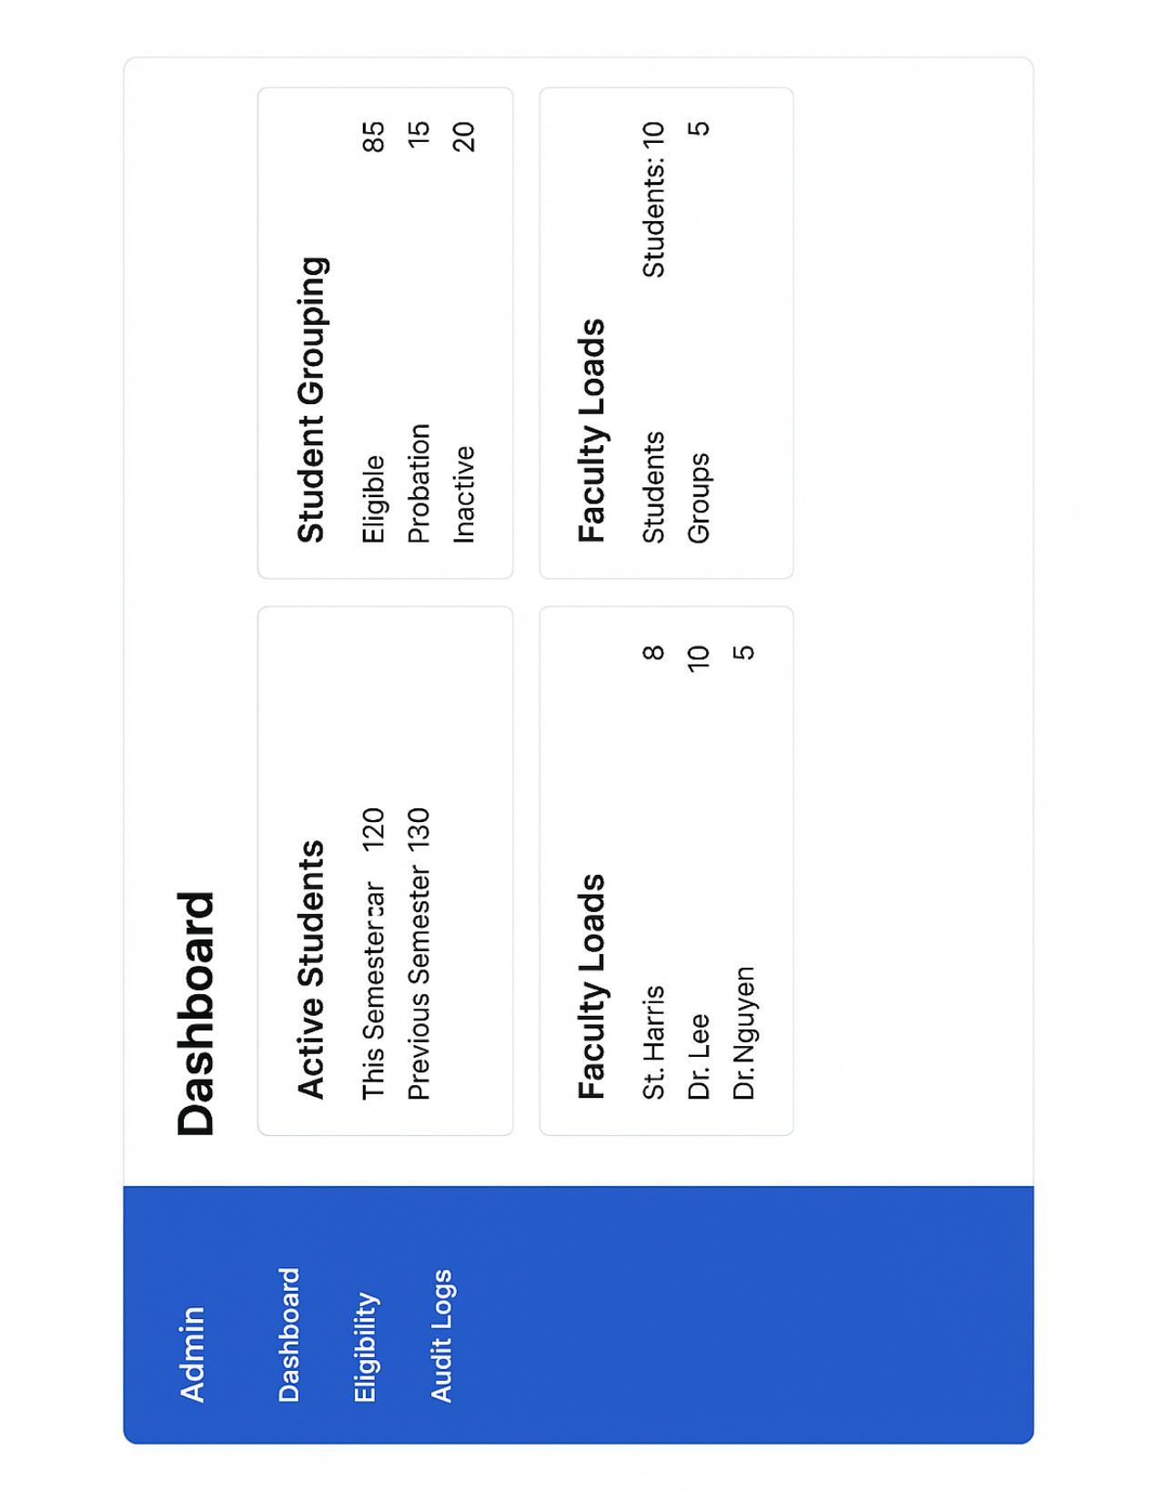
Figure 2.1
The system is accessible through two React.js single-page applications -- one for students and faculty, and one for administrators -- both communicating with backend services exclusively through the NGINX API gateway. All services are containerized using Docker and designed to scale horizontally, with stateless service instances backed by shared PostgreSQL and MongoDB databases. Real-time communication is handled through WebSocket connections managed by the Notification Service, with Apache Kafka serving as the asynchronous event bus between services.

High Level Architecture Diagram:
The high-level architecture diagram below illustrates the primary components of Acad Connect and the communication pathways between them. Client requests from both the Student/Faculty Interface and the Admin Interface flow through the NGINX API Gateway, which handles routing, authentication verification, and rate limiting before forwarding requests to the appropriate microservice. The five backend microservices -- User Service, Project Service, Notification Service, Recommendation Service, and Snippet Feedback Service -- operate independently and communicate with one another through Kafka event topics for asynchronous operations and direct HTTP calls for synchronous queries.

Architecture Subsystems:
The Acad Connect architecture is organized into five distinct layers: the Client Layer, the API Gateway Layer, the Microservices Layer, the Data Layer, and External Services. Each layer encapsulates a specific tier of responsibility, enabling teams to develop, test, and deploy individual components without impacting the rest of the system. The subsections below describe each layer's role and composition.

Client Layer (Student & Faculty Interfaces):
The Client Layer consists of two React.js single-page applications. The Student and Faculty Interface provides role-specific dashboards for profile management, faculty discovery, project snippet submission, mentorship request management, and project progress tracking. The Admin Interface provides a separate dashboard for eligibility management, audit log review, and platform-wide supervision metrics. Both applications communicate exclusively with the backend through the NGINX API Gateway using RESTful HTTP requests and WebSocket connections for real-time updates.

API Gateway Layer:
The API Gateway is implemented using NGINX and serves as the single entry point for all client requests. It is responsible for request routing to the appropriate downstream microservice, JWT-based authentication validation, rate limiting to prevent abuse, and load balancing across service replicas. By centralizing these cross-cutting concerns in the gateway, individual microservices are relieved of authentication and routing logic, keeping them focused on their core domain responsibilities.

Microservices Layer:
The Microservices Layer comprises five independently deployable services, each built around a specific bounded context. The User Service and Project Service are implemented in Node.js, while the Recommendation Service and Snippet Feedback Service are Python-based FastAPI/Flask applications optimized for NLP workloads. The Notification Service bridges the synchronous REST world and the asynchronous Kafka event stream, delivering both in-app WebSocket notifications and email alerts through SendGrid. Each service exposes a well-defined REST API and publishes or consumes Kafka topics for inter-service communication.

Data Layer:
The Data Layer uses a polyglot persistence strategy with two database technologies selected to match the nature of the data they store. PostgreSQL serves as the primary relational database for all structured data including user profiles, project records, mentorship requests, supervision capacity, and milestone tracking. MongoDB is used for unstructured NLP artifacts such as project snippets, AI feedback results, and recommendation outputs. This separation allows each database to be optimized independently -- PostgreSQL with relational indexes and foreign key constraints, and MongoDB with document-oriented queries suited for variable-schema NLP data.
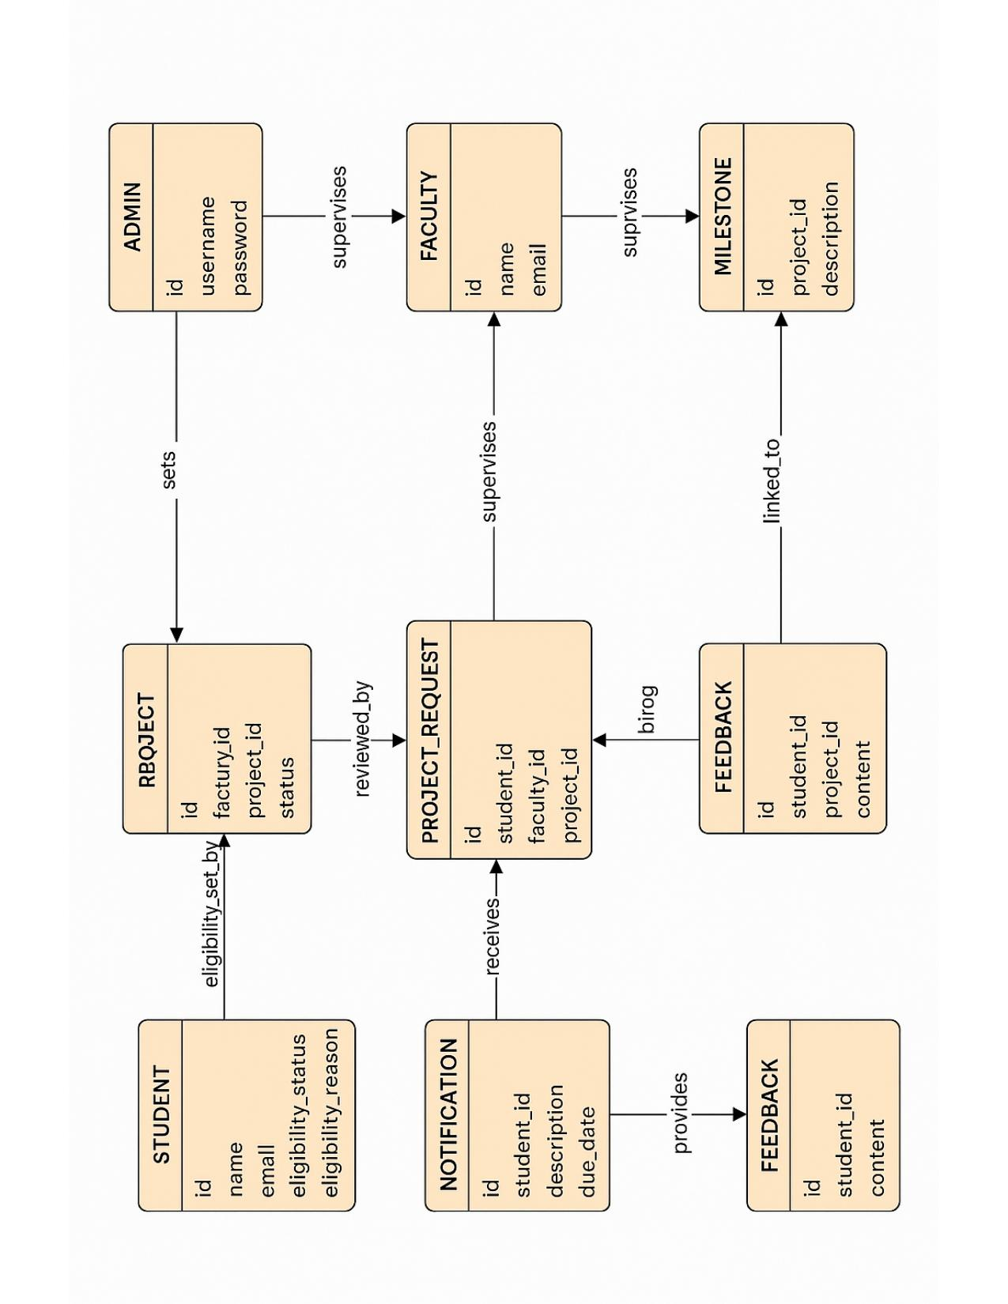
Figure 2.2 Entity Relationship Diagram (ERD) for Acad Connect database schema

External Services:
Acad Connect integrates with three external services. SendGrid provides reliable transactional email delivery for faculty responses, project update notifications, and system alerts. The ML Models component -- encompassing the TF-IDF recommendation engine and NLP feedback models -- is hosted within the Python AI services and may be extended to use external embedding APIs such as OpenAI or Hugging Face in future iterations. A Chatbot API integration provides conversational onboarding and FAQ support, implemented using a framework such as Rasa or Dialogflow, accessible to students through the platform interface.

Microservices Description:
The following subsections provide a detailed description of each microservice's responsibilities, technology stack, and key API interactions. Together, these five services form the complete operational backbone of Acad Connect.
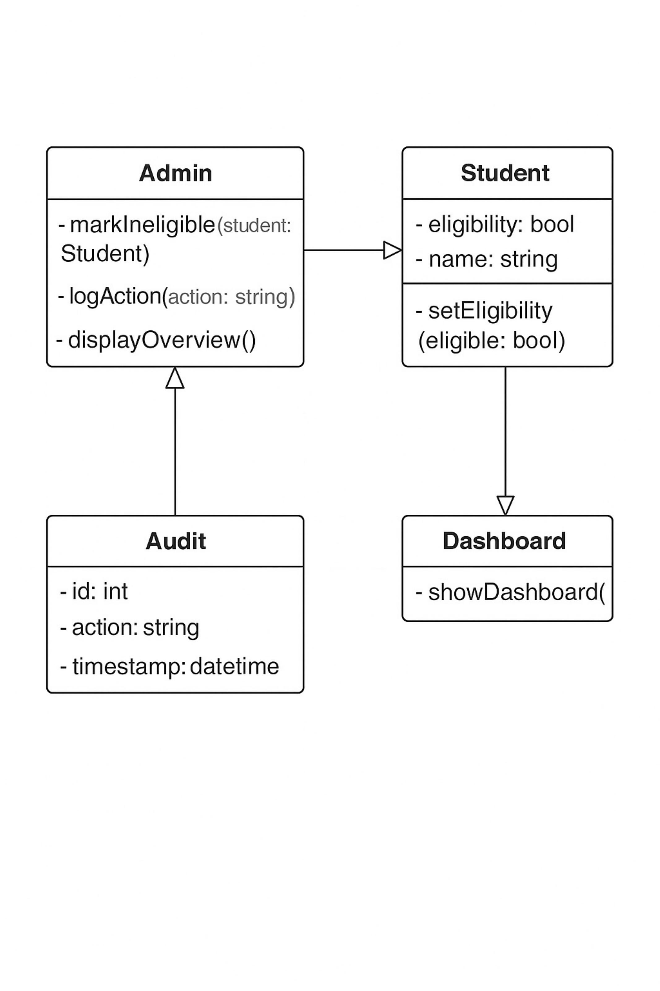
Figure 2.3 Admin Class Diagram showing Admin, Audit, Student, and Dashboard entities

User Service:
The User Service, built with Node.js and Express, handles all authentication and profile management operations for both students and faculty. It is responsible for user registration and login with JWT token issuance, profile creation and updates including skills, research interests, and department affiliations, and role-based access control. The service maintains user records in PostgreSQL and exposes REST endpoints consumed by the frontend and the API gateway for token validation. It also publishes user-related events to Kafka topics that downstream services such as the Recommendation Service consume to maintain synchronized faculty expertise profiles.
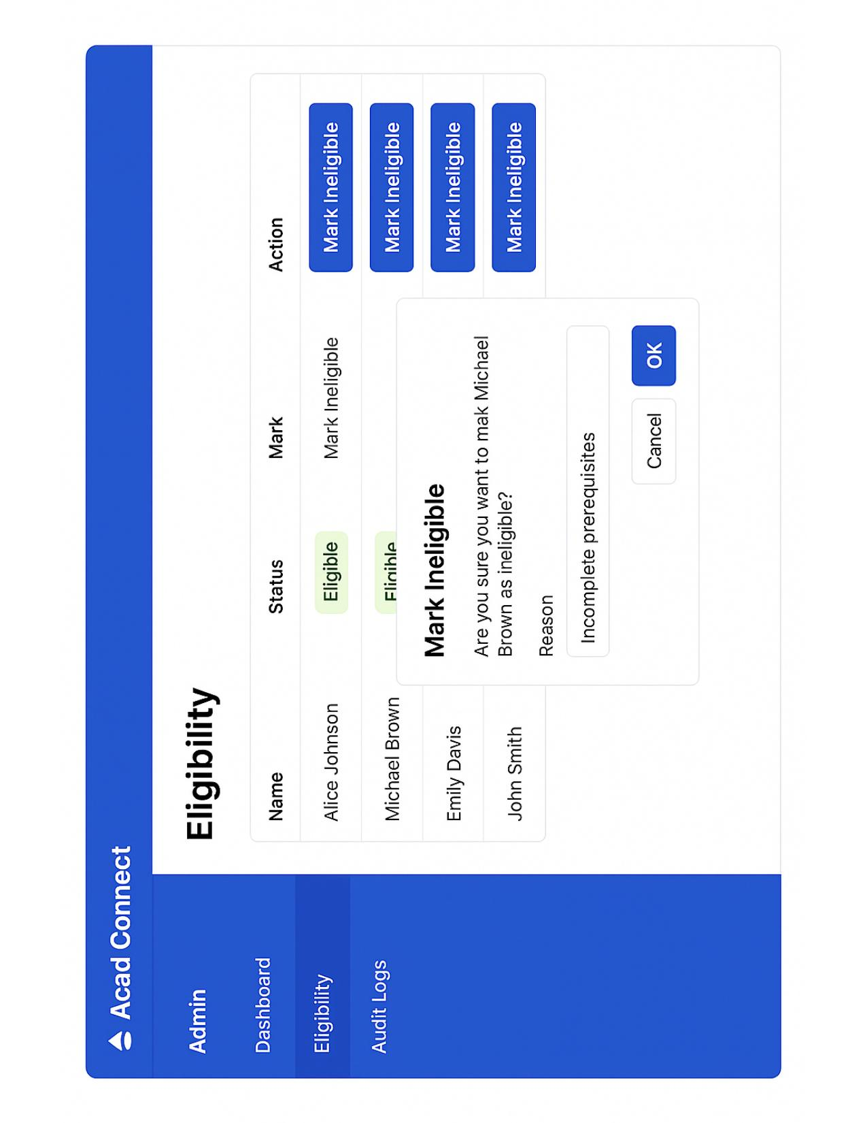
Figure 2.4 Eligibility Management UI showing student status and admin actions

Project Service:
The Project Service manages the complete lifecycle of academic project collaborations. It handles the creation, retrieval, and status updates of project records; the submission and validation of 200-word project snippets; the management of mentorship requests including acceptance, rejection, and withdrawal; and the enforcement of faculty supervision capacity limits through automatic slot closure when a faculty member reaches their defined maximum. The service maintains project records and request state in PostgreSQL, publishes status-change events to Kafka for the Notification Service, and coordinates with the Feedback and Recommendation Services for AI-driven operations.

Notification Service:
The Notification Service is a Node.js service that acts as the real-time communication hub of the platform. It consumes events published to Kafka topics by other services -- such as request status changes from the Project Service or milestone updates -- and delivers them to the appropriate recipients via two channels: WebSocket connections for in-app real-time notifications and SendGrid API calls for email alerts. The service maintains notification records in PostgreSQL to support notification history views and read/unread status tracking in the frontend.

Recommendation Service:
The Recommendation Service is a Python-based FastAPI application that provides AI-driven faculty matching for students. Given a student's project snippet text, the service computes TF-IDF similarity scores between the snippet and faculty expertise profiles indexed in the database, returning a ranked list of recommended advisors along with match scores and explanatory keywords. The service queries faculty profile data from PostgreSQL through an internal API call to the User Service and stores recommendation results in MongoDB for retrieval by the frontend. The architecture is designed to be extensible, allowing the TF-IDF baseline to be replaced or augmented with dense vector embeddings using pgvector or Pinecone in future releases.

Snippet Feedback Service:
The Snippet Feedback Service is a Python-based Flask/FastAPI application that provides real-time NLP analysis of student project snippets. When a student submits or revises a snippet, the service performs word count validation, clarity scoring based on sentence structure and vocabulary complexity, keyword extraction to identify research themes, and identification of suggested improvement areas. Feedback results are stored in MongoDB as structured documents and returned to the student through the frontend interface, enabling iterative refinement before final submission. This service reduces the burden on faculty to review poorly structured or unclear proposals, improving the overall quality of mentorship requests received.

System Data Overflow:
The primary data flow in Acad Connect follows the student project request lifecycle. A student logs in through the Student Interface, which authenticates via the User Service through the API Gateway. The student submits a project snippet, which is validated and stored by the Project Service and simultaneously sent to the Snippet Feedback Service for NLP analysis. The student may then request faculty matching, triggering a call to the Recommendation Service which returns a ranked list of advisors. Upon selecting a faculty member, the student submits a mentorship request through the Project Service, which persists the request and publishes a Kafka event. The Notification Service consumes this event and delivers an in-app and email notification to the targeted faculty member.
Faculty members review requests through the Faculty Interface, with acceptance or rejection handled by the Project Service. Status change events flow back through Kafka to the Notification Service, which alerts the student. Once a project is accepted, both parties interact with the platform for progress milestone updates, which are also propagated through the notification pipeline. All inter-service communication is secured with internal service tokens, and all client-facing API calls are authenticated at the gateway level.

Security and Authentication Model:
Acad Connect implements a layered security model aligned with industry best practices for web application security. Authentication is handled through JSON Web Tokens (JWT) issued by the User Service upon successful login. The NGINX API Gateway validates JWT tokens on every incoming request before routing to downstream services, ensuring that unauthenticated requests are rejected at the perimeter. Role-based access control (RBAC) is enforced at the service level, with each endpoint restricted to the appropriate user role -- student, faculty, or administrator -- based on the role claim embedded in the JWT payload.
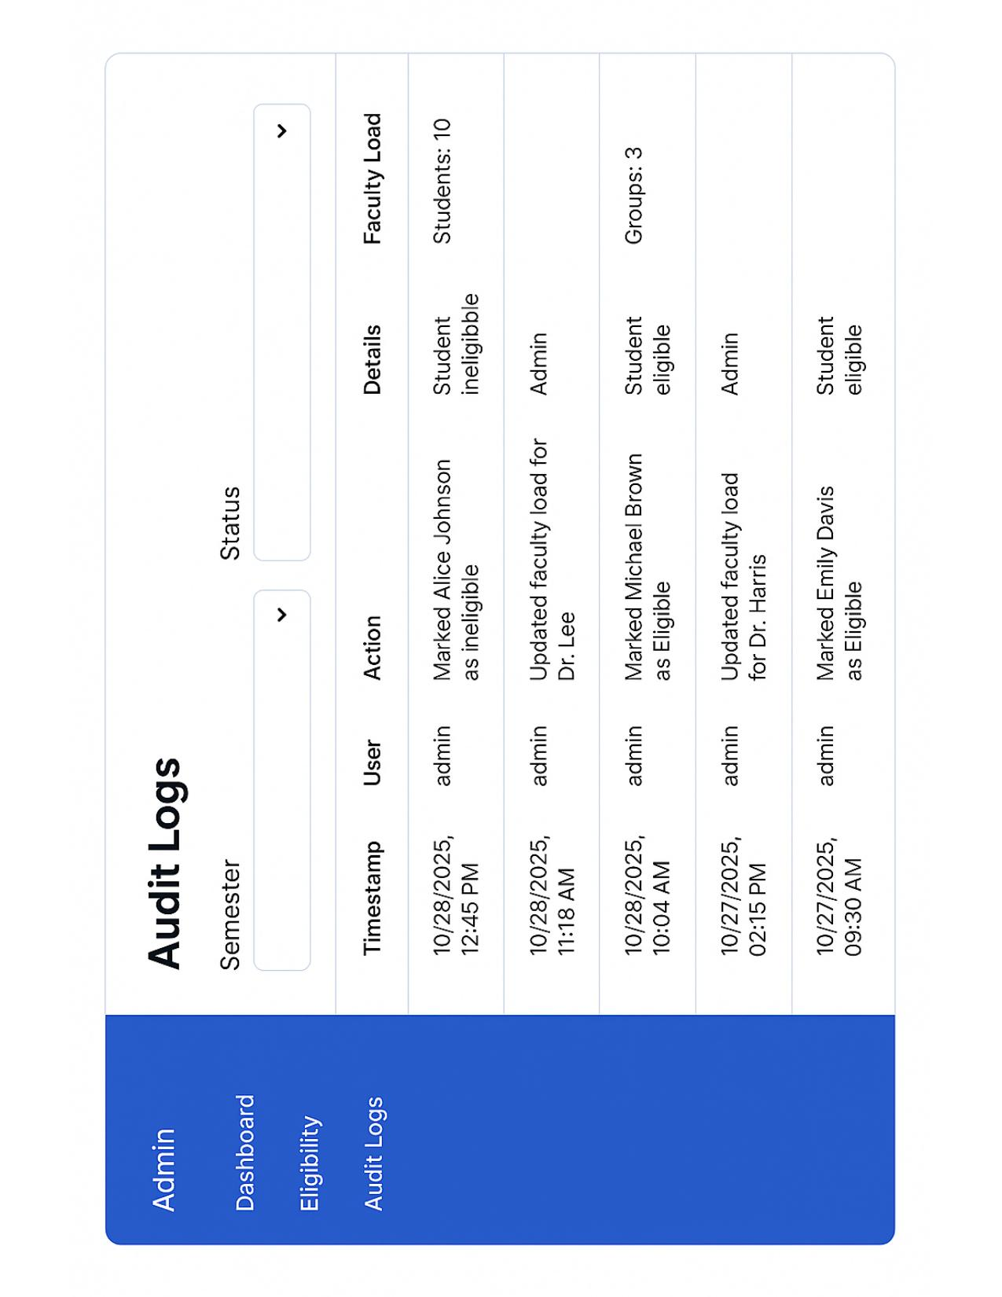
Figure 2.5 Audit Logs UI displaying timestamped admin actions and system events
Data security is maintained through encrypted communication over HTTPS for all client-server interactions and TLS for inter-service communication within the container network. Sensitive user data including passwords is stored as salted bcrypt hashes. The platform's audit logging system, managed through the Admin Service, records all administrative actions with timestamps and user identifiers to support accountability and compliance. Future iterations may incorporate OAuth 2.0 and university SSO integration to streamline authentication for institutional deployments.

Scalability Considerations:
The microservices architecture of Acad Connect is inherently designed for horizontal scalability. Each service is stateless and containerized, allowing multiple replicas to be deployed behind the NGINX load balancer during periods of high demand -- particularly during project proposal deadlines and semester start periods. The use of Apache Kafka as an asynchronous event bus decouples services and prevents cascading failures; if the Notification Service experiences increased load, unprocessed events are buffered in Kafka topics rather than blocking upstream services.
At the data tier, PostgreSQL supports read replicas for scaling read-heavy query patterns, while MongoDB's document model accommodates flexible schema evolution as NLP data structures evolve over time. Database connection pooling is managed at the service level to prevent connection exhaustion under concurrent load. The platform is designed to meet its non-functional requirement of supporting at least 500 concurrent users without degradation, with the containerized deployment strategy providing a clear path to scaling individual services independently as usage patterns are observed in production.

Technology Descriptions
Assume you audience is a skilled computer scientist that has some familiarity with technologies taught in the client/server program. The topics below are for a typical MS Software Engineering project. Adjust the topics in this chapter to meet the needs of your project.

Client Technologies

React.js:
React.js is the frontend framework used for both the Student/Faculty Interface and the Admin Interface in Acad Connect. React's component-based architecture enables the development of reusable, modular UI elements such as profile cards, request tables, snippet editors, and notification panels, each managed as independent components with their own state. The use of React's virtual DOM ensures efficient re-rendering, which is particularly important for real-time views that update in response to WebSocket notifications without requiring full page reloads.
React Router is used for client-side navigation between views such as the dashboard, faculty discovery, and project tracking pages, providing a single-page application (SPA) experience. State management across components is handled using React Context and the useState/useReducer hooks, keeping the application lightweight without requiring a heavier library such as Redux for the current feature scope.

UI Component Libraries:
Acad Connect's frontend leverages a UI component library to maintain visual consistency and accelerate development. Standard components such as data tables, modal dialogs, form inputs, status badges, and navigation sidebars are sourced from the library, ensuring that all user-facing elements adhere to a unified design language across both the student/faculty and admin interfaces. The Admin Dashboard, Eligibility Management, and Audit Logs views in particular rely on pre-built table and filter components to display structured data cleanly.
Styling is managed through a combination of the component library's theming system and custom CSS modules, allowing per-component style overrides without global style conflicts. The platform follows WCAG 2.1 accessibility guidelines, ensuring that color contrast ratios, keyboard navigation, and screen reader compatibility are maintained across all views.

WebSocket Client Integration:
Real-time notifications in Acad Connect are delivered to the frontend through WebSocket connections managed by the browser's native WebSocket API. Upon login, the client establishes a persistent WebSocket connection to the Notification Service through the NGINX gateway. Incoming events -- such as faculty acceptance or rejection of a project request, or a new milestone update -- are received as JSON payloads and dispatched to the relevant React component state, triggering an immediate UI update without requiring the user to refresh the page.
The WebSocket connection includes reconnection logic to handle temporary network interruptions gracefully, ensuring notification delivery resumes automatically after connectivity is restored. Undelivered notifications are also retrievable from the Notification Service's REST endpoint, so users who were offline during an event can view missed updates upon their next login.

Middle-Tier Technologies

Node.js Backend Services:
The User Service and Project Service are implemented using Node.js with the Express.js framework. Node.js was selected for these services due to its non-blocking, event-driven I/O model, which is well-suited to handling concurrent HTTP requests from multiple students and faculty members interacting with the platform simultaneously. Express.js provides a minimal and flexible routing layer that allows each service to expose clean REST API endpoints for CRUD operations on users, projects, requests, and milestones.
Each Node.js service connects to PostgreSQL via the pg or Sequelize ORM library, with connection pooling configured to manage database connections efficiently under load. JWT middleware is applied at the route level to enforce authentication and role-based access control, ensuring that students cannot access faculty-only endpoints and vice versa. The services are stateless by design, enabling horizontal scaling by deploying multiple replicas behind the NGINX load balancer.

Python AI Services (FastAPI/Flask):
The Recommendation Service and Snippet Feedback Service are implemented in Python, chosen for its rich ecosystem of NLP and machine learning libraries. The Recommendation Service uses FastAPI for its high-performance asynchronous request handling and automatic OpenAPI documentation generation, while the Snippet Feedback Service uses Flask for its simplicity and ease of integration with NLP preprocessing pipelines. Both services expose REST endpoints consumed by the Project Service and the frontend through the API gateway.
Python's scikit-learn library provides the TF-IDF vectorization and cosine similarity computation used in the recommendation engine. The spaCy library is used in the Snippet Feedback Service for tokenization, part-of-speech tagging, and keyword extraction. Both services load their NLP models at startup and keep them in memory to minimize per-request latency, with model reloading supported through a lightweight admin endpoint.

Kafka Messaging System:
Apache Kafka serves as the asynchronous messaging backbone of Acad Connect, decoupling event producers from event consumers across microservices. Key events such as project request submissions, faculty accept/reject decisions, and milestone updates are published as messages to dedicated Kafka topics by the Project Service. The Notification Service subscribes to these topics and processes incoming events to generate WebSocket pushes and email notifications, without the Project Service needing to know anything about how notifications are delivered.
Kafka's durable message log ensures that events are not lost if the Notification Service is temporarily unavailable -- messages remain in the topic until they are consumed and acknowledged. This fault tolerance is especially important during high-traffic periods such as project proposal deadlines, when bursts of simultaneous request submissions could otherwise overwhelm a synchronous notification pipeline. Kafka is deployed as a containerized service within the Docker Compose environment alongside ZooKeeper for cluster coordination.

API Gateway (NGINX):
NGINX serves as the API gateway and reverse proxy for all client-server communication in Acad Connect. All HTTP and WebSocket traffic from the React frontends is routed through NGINX, which maps URL path prefixes to the appropriate backend microservice -- for example, routing /api/users/* to the User Service and /api/projects/* to the Project Service. This centralized routing eliminates the need for clients to know the addresses of individual services and simplifies service discovery.
In addition to routing, the NGINX gateway handles SSL/TLS termination, JWT token validation via a Lua-based authentication module, rate limiting per client IP to prevent abuse, and load balancing across multiple replicas of each service using a round-robin strategy. NGINX configuration is managed as code within the Docker Compose setup, ensuring consistent gateway behavior across development, staging, and production environments.

Data-Tier Technologies

PostgreSQL Relational Database:
PostgreSQL is the primary relational database for Acad Connect, storing all structured data including user accounts, faculty profiles, student records, project details, mentorship requests, supervision capacity counters, and milestone records. PostgreSQL was chosen for its ACID compliance, robust support for complex relational queries with joins and foreign key constraints, and its extensibility through the pgvector extension, which may be used in future iterations to store and query dense vector embeddings for semantic faculty matching.
The database schema enforces referential integrity between entities -- for example, a ProjectRequest record must reference a valid Student, Faculty, and Snippet record -- preventing orphaned records and maintaining data consistency across the system. Partial unique indexes are used to enforce business rules such as limiting each student to one active project at a time. Database migrations are managed using a schema migration tool to ensure consistent schema state across all deployment environments.

MongoDB NoSQL Database:
MongoDB is used alongside PostgreSQL to store unstructured and semi-structured data that does not fit well into a relational schema. Specifically, MongoDB stores NLP artifacts including project snippet documents, AI feedback results with variable-length suggestion arrays, recommendation output records with embedded score arrays, and chatbot interaction logs. The document-oriented model allows these records to carry flexible nested structures without requiring schema migrations each time the AI output format evolves.
MongoDB collections are accessed by the Recommendation Service and Snippet Feedback Service through the PyMongo driver, and by the Notification Service for storing notification history documents. Indexes are defined on frequently queried fields such as studentID and snippetID to ensure query performance remains acceptable as the volume of NLP records grows. MongoDB is deployed as a containerized service within the same Docker Compose environment as the other platform components.

Database Indexing and Optimization:
Database performance is maintained through a combination of indexing strategies applied to both PostgreSQL and MongoDB. In PostgreSQL, B-tree indexes are defined on foreign key columns such as student_id, faculty_id, and project_id in the ProjectRequest and Project tables to accelerate join queries. A partial unique index on the Project table enforces the one-active-project-per-student constraint efficiently at the database level. Frequently filtered columns such as request status and user role also carry indexes to support dashboard and listing queries.
In MongoDB, compound indexes on snippetID and createdAt allow the Feedback Service to retrieve the most recent feedback for a given snippet efficiently. Connection pooling is configured at the application level in both Node.js and Python services to reuse database connections across requests, reducing the overhead of connection establishment under concurrent load. Query execution plans are reviewed during testing and slow queries are identified using PostgreSQL's EXPLAIN ANALYZE and MongoDB's explain() method for targeted optimization.

AI and NLP Technologies

TF-IDF Based Recommendation Engine:
The faculty recommendation engine in Acad Connect is built on Term Frequency-Inverse Document Frequency (TF-IDF) vectorization combined with cosine similarity scoring. When a student submits a project snippet, the Recommendation Service vectorizes the snippet text using a TF-IDF model fitted on the corpus of faculty research area descriptions and expertise summaries stored in the database. Cosine similarity is then computed between the snippet vector and each faculty profile vector, producing a ranked list of recommended advisors sorted by relevance score.
The TF-IDF model is implemented using scikit-learn's TfidfVectorizer, with stop word removal and n-gram range tuned to capture both individual keywords and two-word research phrases such as 'machine learning' or 'distributed systems'. The recommendation results include the top-K faculty matches along with the contributing keywords that drove each match score, providing students with explainable recommendations rather than opaque rankings. The architecture is designed to be extensible -- the TF-IDF vectors can be replaced with dense sentence embeddings from models such as BERT or sentence-transformers stored in pgvector for improved semantic matching in future releases.

NLP Processing for Snippet Analysis:
The Snippet Feedback Service applies a multi-step NLP pipeline to student project snippets to evaluate clarity, compliance, and keyword richness. The pipeline first validates the snippet against the 200-word limit, then applies spaCy's English language model to tokenize the text and compute sentence-level readability metrics. A clarity score from 0 to 5 is assigned based on factors including average sentence length, passive voice frequency, and lexical diversity. Identified issues -- such as overly long sentences, ambiguous phrasing, or insufficient technical vocabulary -- are returned as structured suggestions to guide the student in revision.
Keyword extraction is performed using a combination of spaCy's noun chunk detection and TF-IDF term weighting against a domain-specific corpus of computer science and engineering research terms. Extracted keywords are mapped to known research areas in the system to produce a list of recommended faculty research domains aligned with the snippet content. This keyword-to-area mapping bridges the gap between the student's natural language description and the structured research area taxonomy used for faculty matching.

Chatbot Integration:
Acad Connect includes a conversational chatbot assistant designed to guide students through platform onboarding, answer frequently asked questions, and provide contextual help during key workflows such as profile setup, snippet submission, and faculty browsing. The chatbot is accessible from a persistent widget in the student interface and responds to natural language queries about platform features, deadlines, and navigation.
The chatbot is implemented using an intent-based dialogue framework such as Rasa or Dialogflow, with a predefined set of intents covering common student interactions -- for example, 'How do I submit a snippet?', 'What is my request status?', and 'Who are the available faculty in machine learning?'. Responses are templated and drawn from a knowledge base maintained by the platform administrators. The chatbot integration is designed to be stateless from the backend perspective, with conversation context managed client-side, minimizing backend load for FAQ-style interactions.

Containerization and Infrastructure

Docker:
All components of Acad Connect -- including the five microservices, NGINX gateway, PostgreSQL, MongoDB, Kafka, and ZooKeeper -- are containerized using Docker. Each service has a dedicated Dockerfile that defines its runtime environment, dependencies, and startup command, ensuring that the service behaves identically across development, testing, staging, and production environments. Docker eliminates the 'works on my machine' problem by packaging each service with its exact dependency versions.
A Docker Compose file at the repository root orchestrates the full multi-container environment for local development and testing. Service dependencies are declared explicitly -- for example, the Project Service container waits for PostgreSQL to be healthy before starting -- ensuring correct startup order. Named Docker volumes persist database data across container restarts, and a shared Docker network enables inter-service communication by service name without exposing internal ports to the host system.

CI/CD Pipeline:
Acad Connect uses a GitHub Actions-based CI/CD pipeline to automate testing, building, and deployment of all services. On every pull request, the pipeline runs unit and integration tests for all microservices in parallel using containerized test environments that mirror the production configuration. Failed tests block merges to the main branch, ensuring that regressions are caught before they reach the deployment pipeline.
On merge to the main branch, the pipeline builds Docker images for all services, tags them with the commit SHA, and pushes them to a container registry. A deployment stage then applies the updated images to the staging environment for smoke testing before promotion to production. Rollback is automated -- if the post-deployment health check fails, the pipeline reverts to the previously deployed image tags within minutes, minimizing downtime.

Cloud Deployment Infrastructure:
Acad Connect is designed for deployment on a cloud infrastructure provider such as AWS, Google Cloud Platform, or Azure, leveraging managed services to reduce operational overhead. The containerized microservices are deployed on a container orchestration platform -- either a managed Kubernetes service such as AWS EKS or GKE, or a simpler platform such as AWS ECS for the initial production deployment. Managed database services such as AWS RDS for PostgreSQL and MongoDB Atlas are used in production to offload database administration, backup, and scaling concerns.
The NGINX API gateway is deployed behind a cloud load balancer that handles SSL termination and distributes incoming traffic across gateway replicas. Static frontend assets are served from a CDN-backed object storage service such as AWS S3 with CloudFront for low-latency global delivery. Infrastructure configuration is managed as code using tools such as Terraform or AWS CloudFormation, enabling reproducible environment provisioning and version-controlled infrastructure changes.

Project Design
This chapter describes the design of Acad Connect at multiple levels of abstraction -- from high-level system workflows and UML diagrams to client-side UI layouts, middle-tier API design, database schema, and the AI recommendation system architecture. The design decisions documented here reflect both the functional requirements established in the project specification and the technical constraints of the chosen microservices stack. Together, these design artifacts provide a comprehensive blueprint for the implementation described in Chapter 5.

Introduction

System Workflow:
Acad Connect supports three distinct user workflows that intersect through the shared project request lifecycle. The following subsections describe the end-to-end flow for each user role, from initial login through to project completion.

Student Workflow:
A student begins by registering and completing their profile with academic details, skills, and areas of interest. They then browse the faculty directory, filtering by research area, and optionally request AI-powered faculty recommendations by submitting a 200-word project snippet. The Snippet Feedback Service analyzes the submission and returns a clarity score with improvement suggestions, enabling the student to refine the snippet before committing to a request. Once satisfied, the student submits a mentorship request targeting one or more faculty members. The student receives in-app and email notifications when a faculty member accepts or rejects the request. Upon acceptance, the student gains access to a project tracking view where they can monitor milestones posted by their advisor.

Faculty Workflow:
A faculty member registers and maintains a profile listing their research areas, ongoing projects, and past supervision history. The system automatically tracks their current supervision count against a defined maximum capacity and closes the request slot once the limit is reached. Incoming student mentorship requests appear in a request management dashboard where the faculty member can review the student's profile and submitted snippet before accepting or rejecting. Upon accepting a request, the faculty member gains access to a project management view where they can post milestone updates visible to the student. All actions trigger notifications to the relevant student via WebSocket and email.

Admin Workflow:
Administrators log in through the dedicated Admin Interface and have access to three primary functions: the Dashboard, the Eligibility Manager, and the Audit Logs viewer. From the Dashboard, administrators can view aggregate statistics including active student counts, faculty supervision loads, and project status distributions. The Eligibility Manager allows administrators to mark individual students as Eligible, on Probation, or Ineligible for project participation, with a reason field recorded for each status change. All administrative actions are automatically logged to the Audit Log with timestamps and the acting administrator's identity, providing a full accountability trail for compliance purposes.

UML Design Diagrams:
The following UML diagrams capture the structural and behavioral design of Acad Connect. The class diagrams define entity attributes and relationships for each user role, while the sequence diagrams illustrate the dynamic message flows for key system interactions.

System Use Case Diagram:
The system use case diagram defines the interactions between the three primary actors -- Student, Faculty, and Admin -- and the core system features. Students interact with profile management, faculty discovery, snippet submission, mentorship requests, AI recommendations, snippet feedback, and progress tracking. Faculty interact with profile management, request acceptance and rejection, capacity management, and milestone updates. Admins interact with student eligibility management, faculty load monitoring, and audit log review. The AI subsystem appears as a secondary actor, interacting with the recommendation and feedback use cases autonomously in response to student snippet submissions.
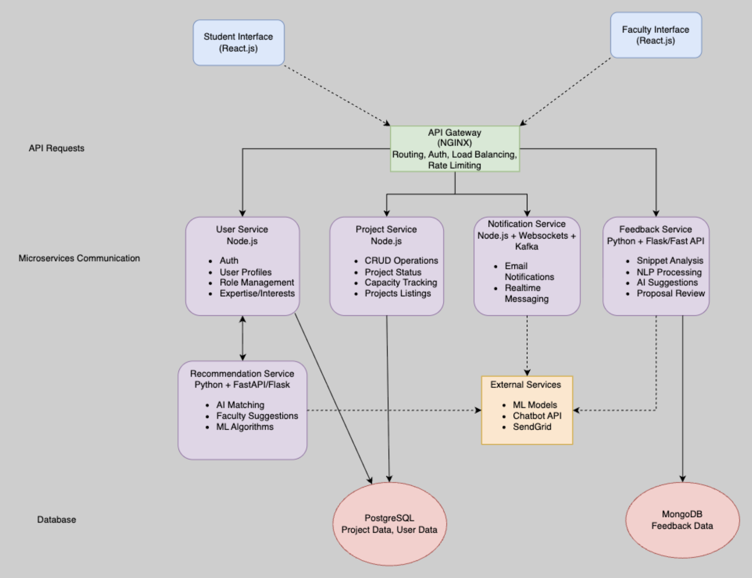
Figure 4.1 Acad Connect System Architecture serving as the high-level use case reference

Class Diagrams:
The class diagrams for Acad Connect are organized by user role domain. The Faculty class diagram models the Faculty, Project, ProjectRequest, ResearchArea, Progress, and Notification entities from the faculty perspective, capturing supervision capacity management and request handling logic. The Student class diagram extends this model with student-specific entities including Snippet, Feedback, and Recommendation, reflecting the AI-driven features available to students. The Admin class diagram captures the Admin, EligibilityManager, AuditLog, NotificationService, and Dashboard entities that support platform governance.
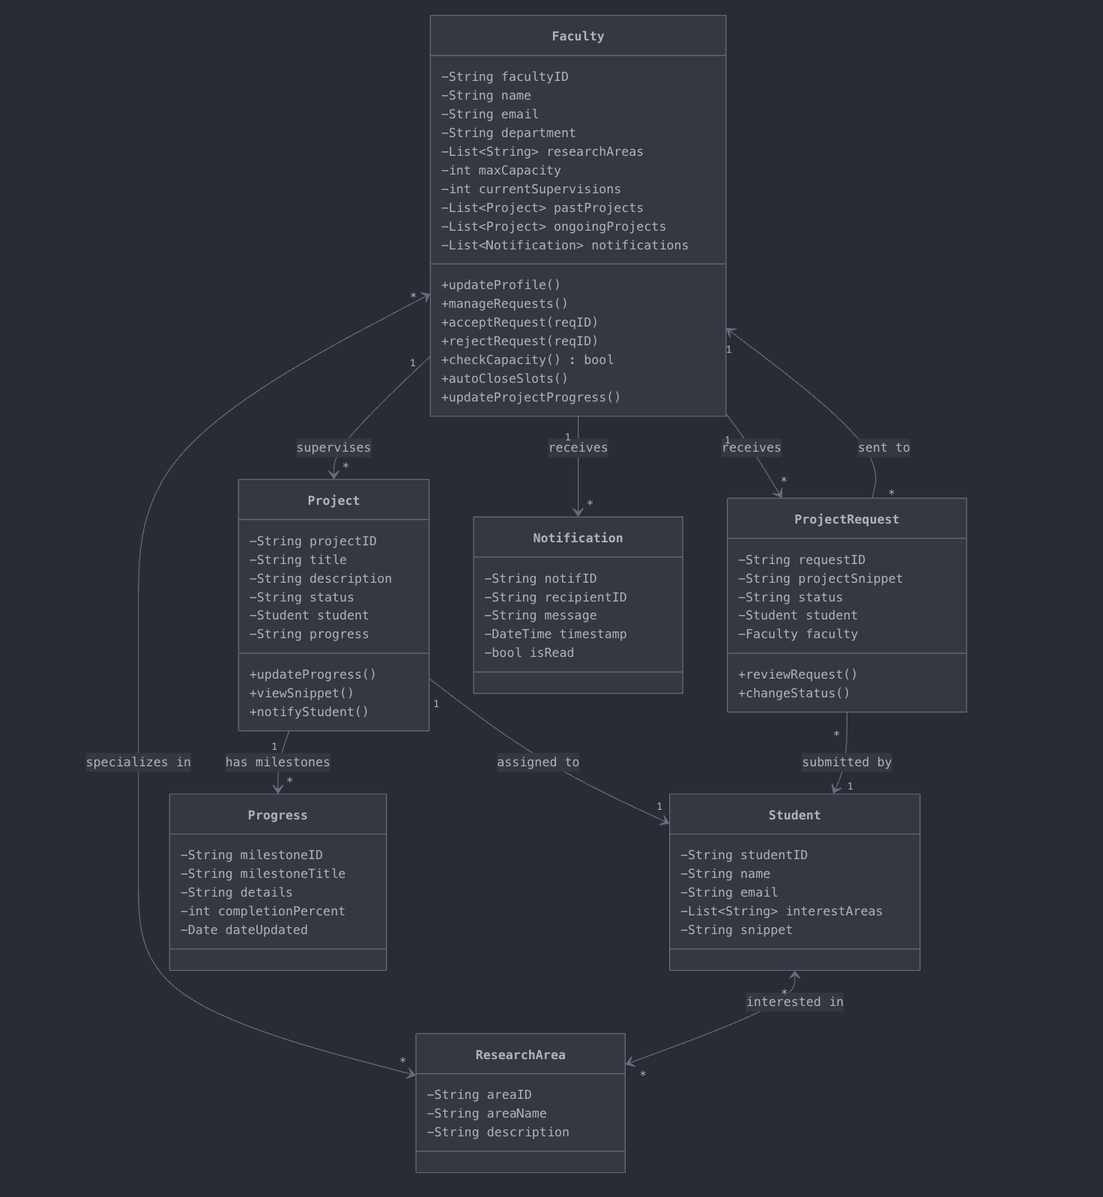
Figure 4.2 Faculty-side UML Class Diagram
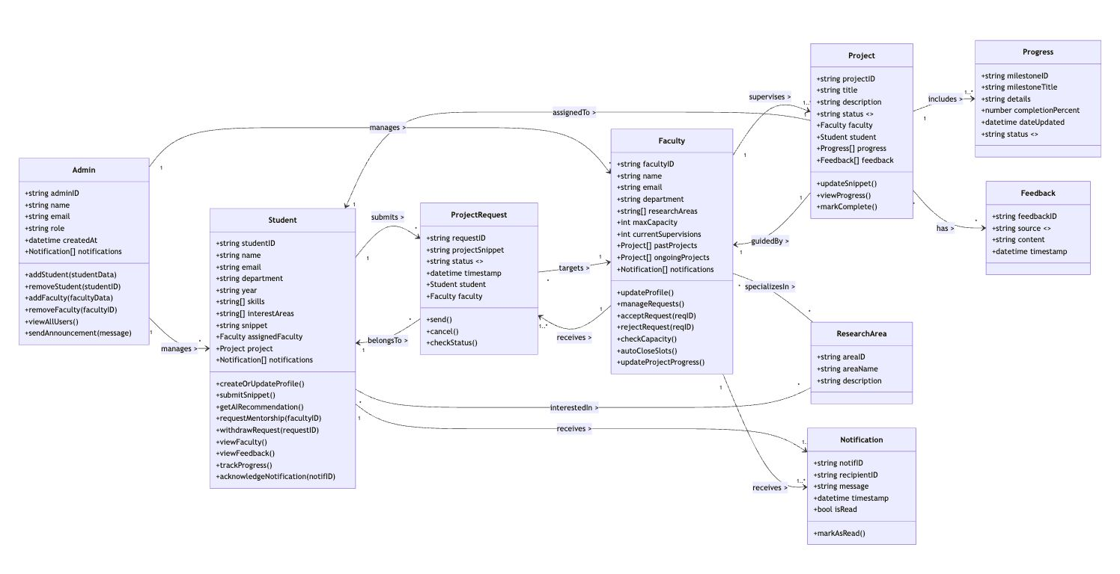
Figure 4.3 Student-side UML Class Diagram

Figure 4.4 Admin-side UML Class Diagram

Sequence Diagrams:
The sequence diagrams below illustrate the dynamic interactions between system components for the key workflows in Acad Connect. Each diagram shows the message flow between the client, API gateway, relevant microservices, and databases for a specific user action, making the temporal ordering of service calls and data operations explicit.
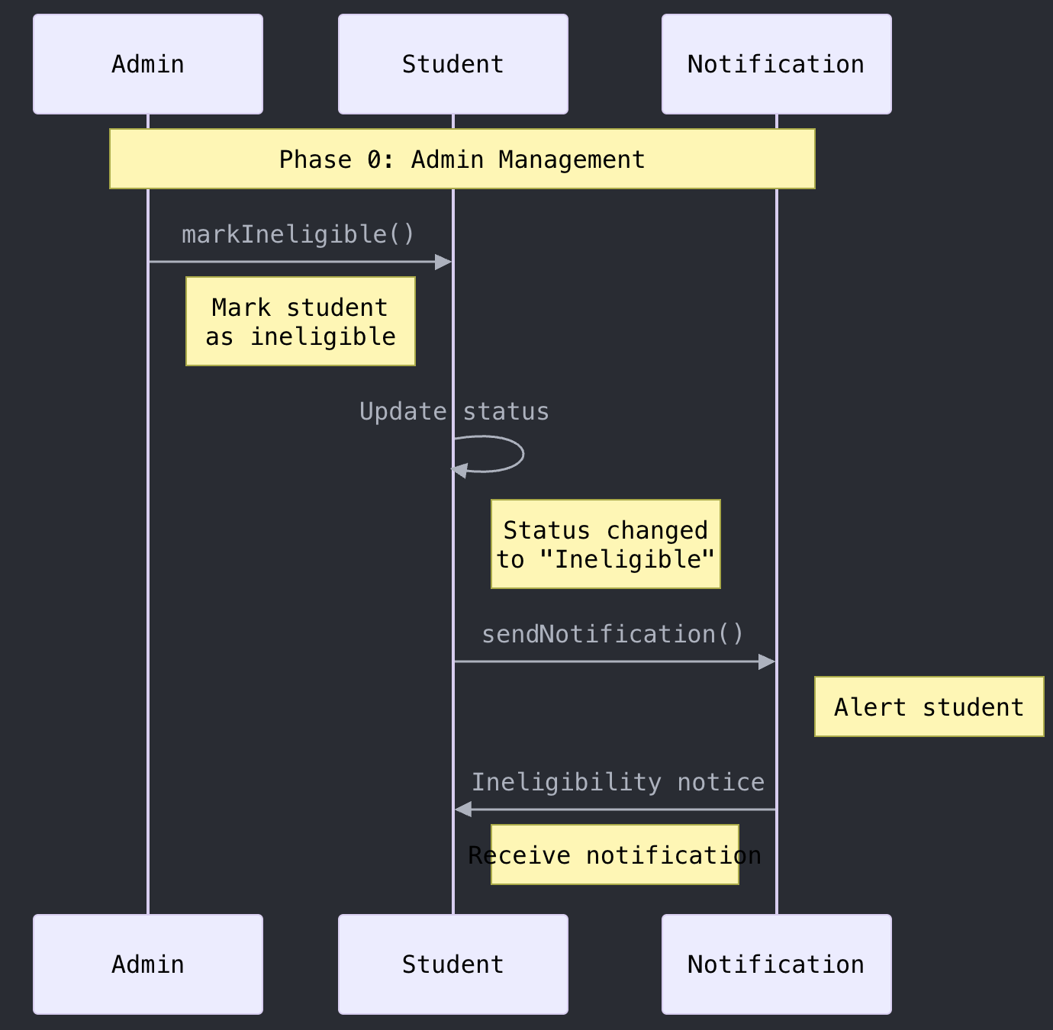
Figure 4.5 Sequence Diagram -- Student Registration and Profile Setup
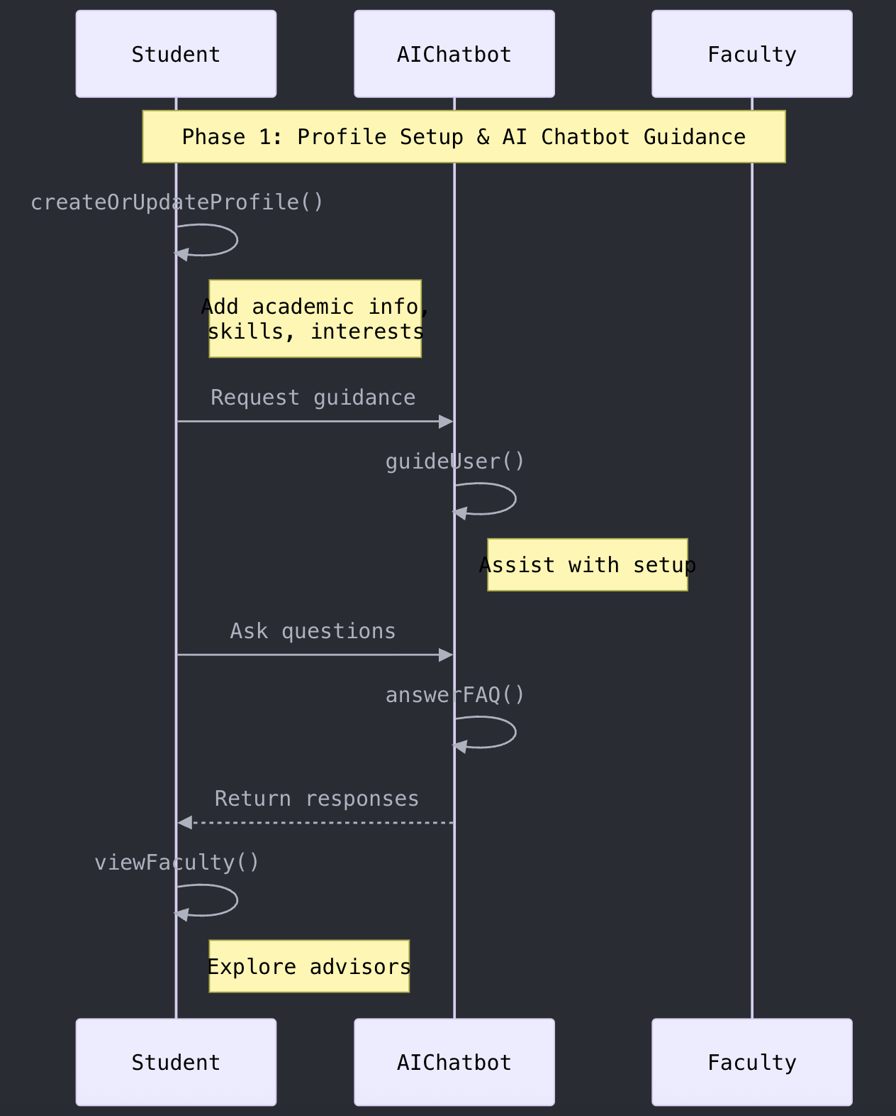
Figure 4.6 Sequence Diagram -- Project Snippet Submission and Feedback
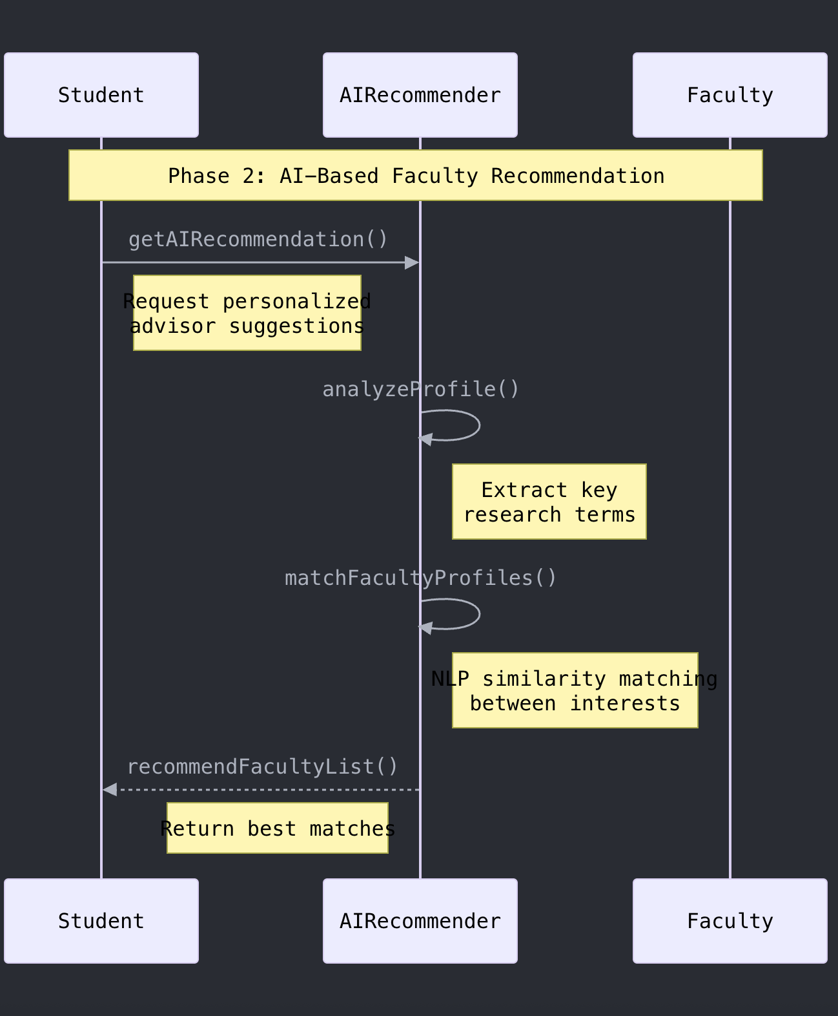
Figure 4.7 Sequence Diagram -- Faculty Recommendation Request
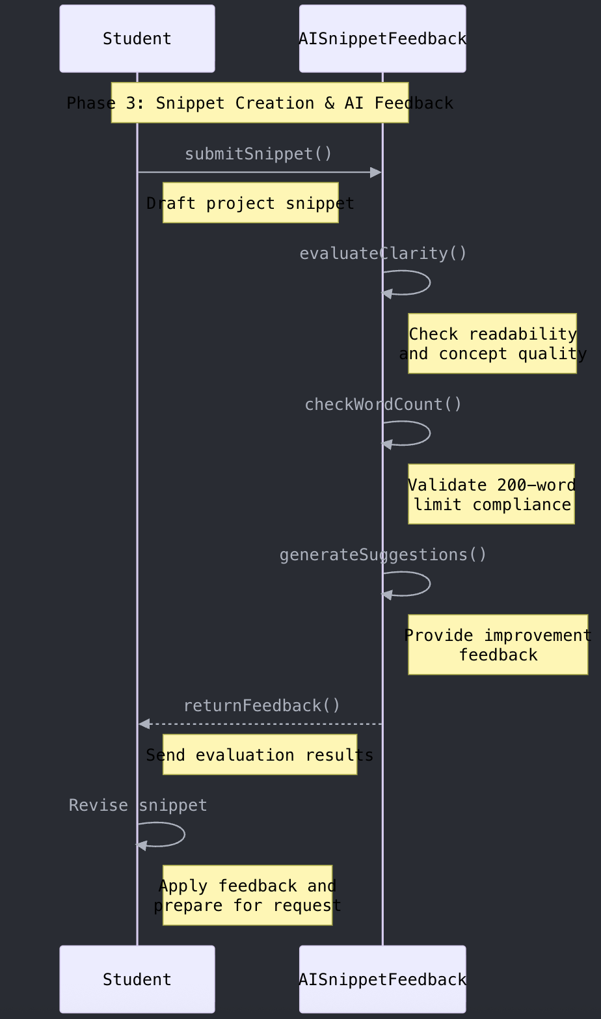
Figure 4.8 Sequence Diagram -- Mentorship Request Submission
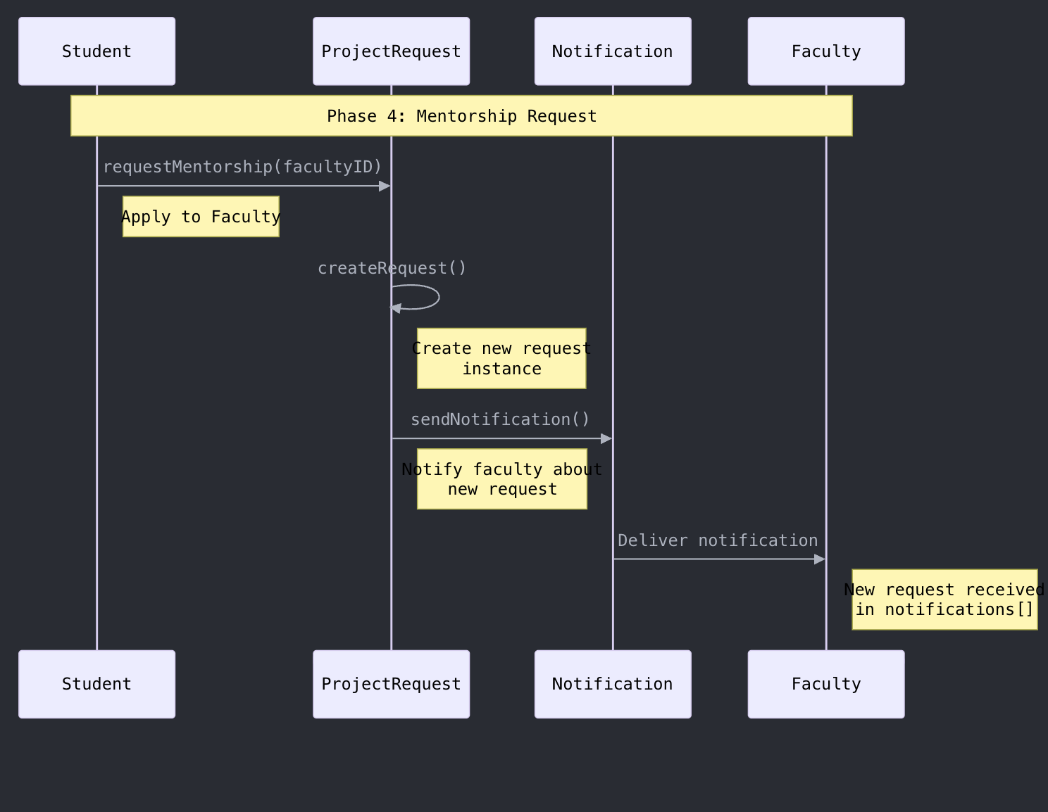
Figure 4.9 Sequence Diagram -- Faculty Accept/Reject Request
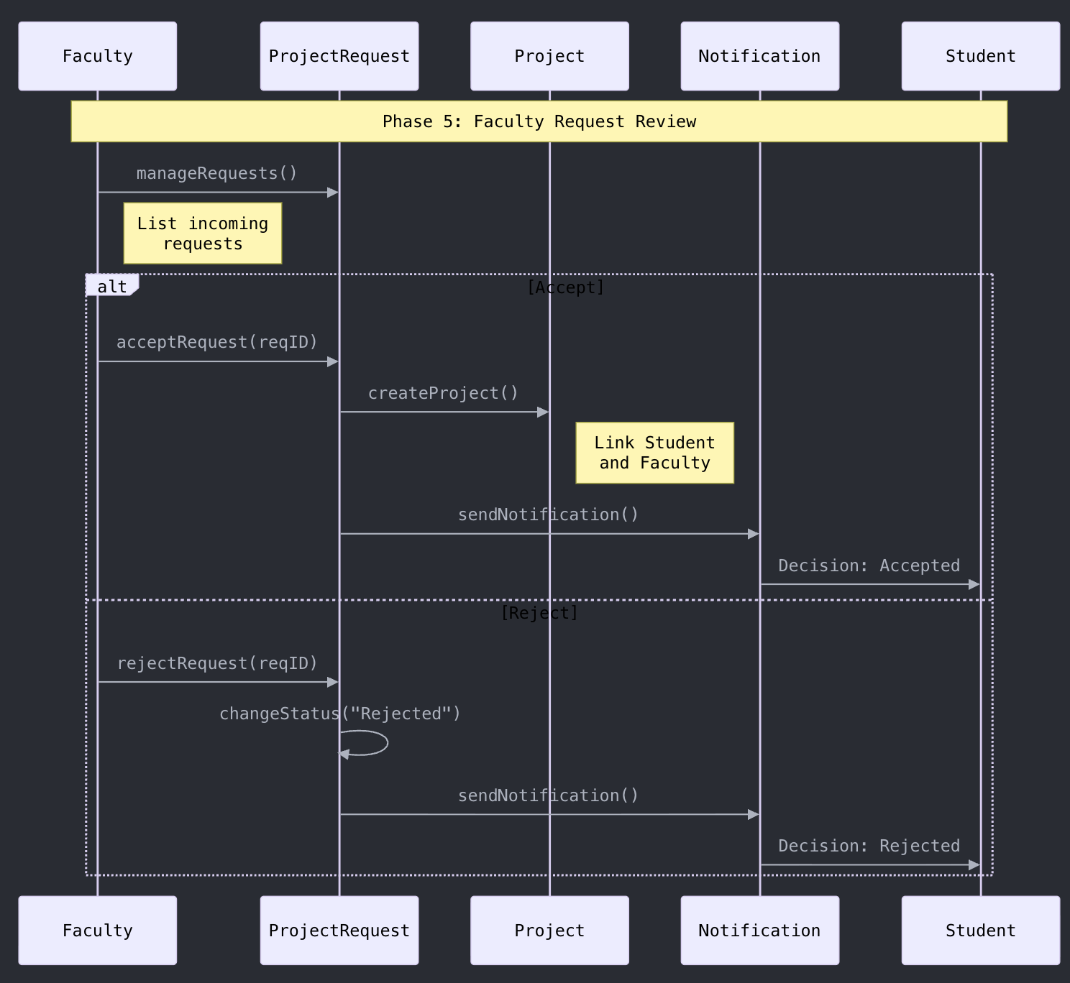
Figure 4.10 Sequence Diagram -- Notification Delivery
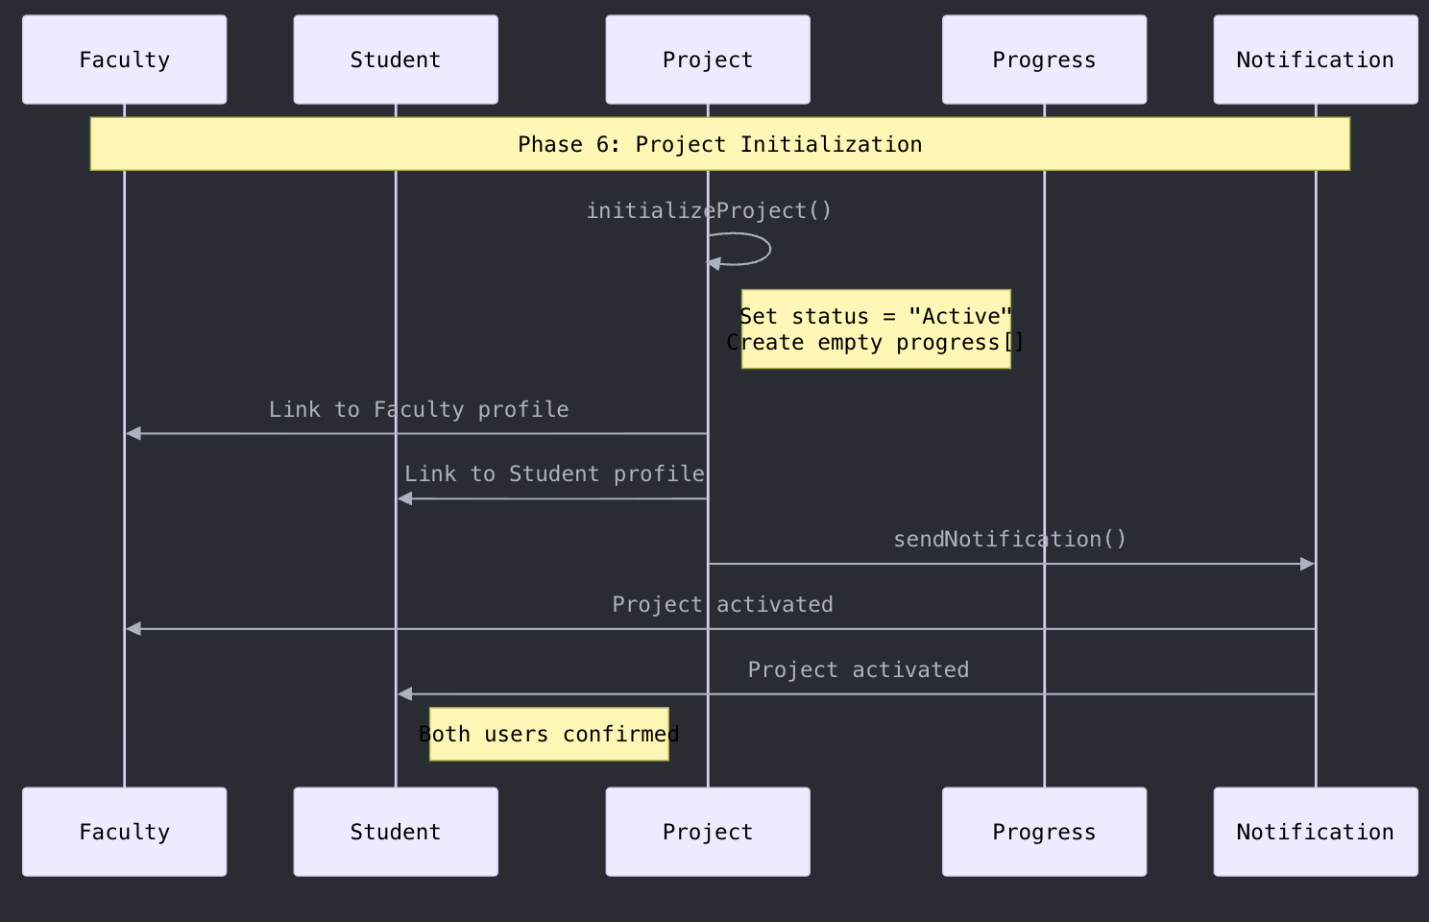
Figure 4.11 Sequence Diagram -- Project Progress Milestone Update
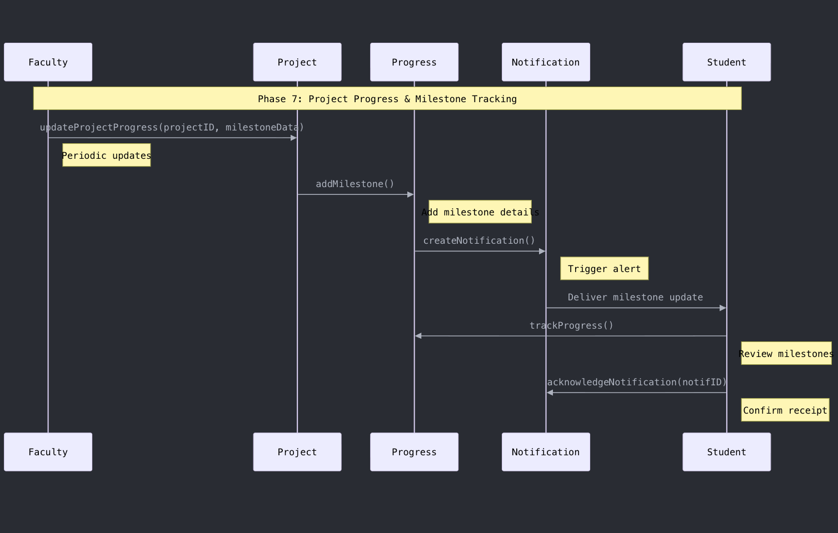
Figure 4.12 Sequence Diagram -- Admin Eligibility Update
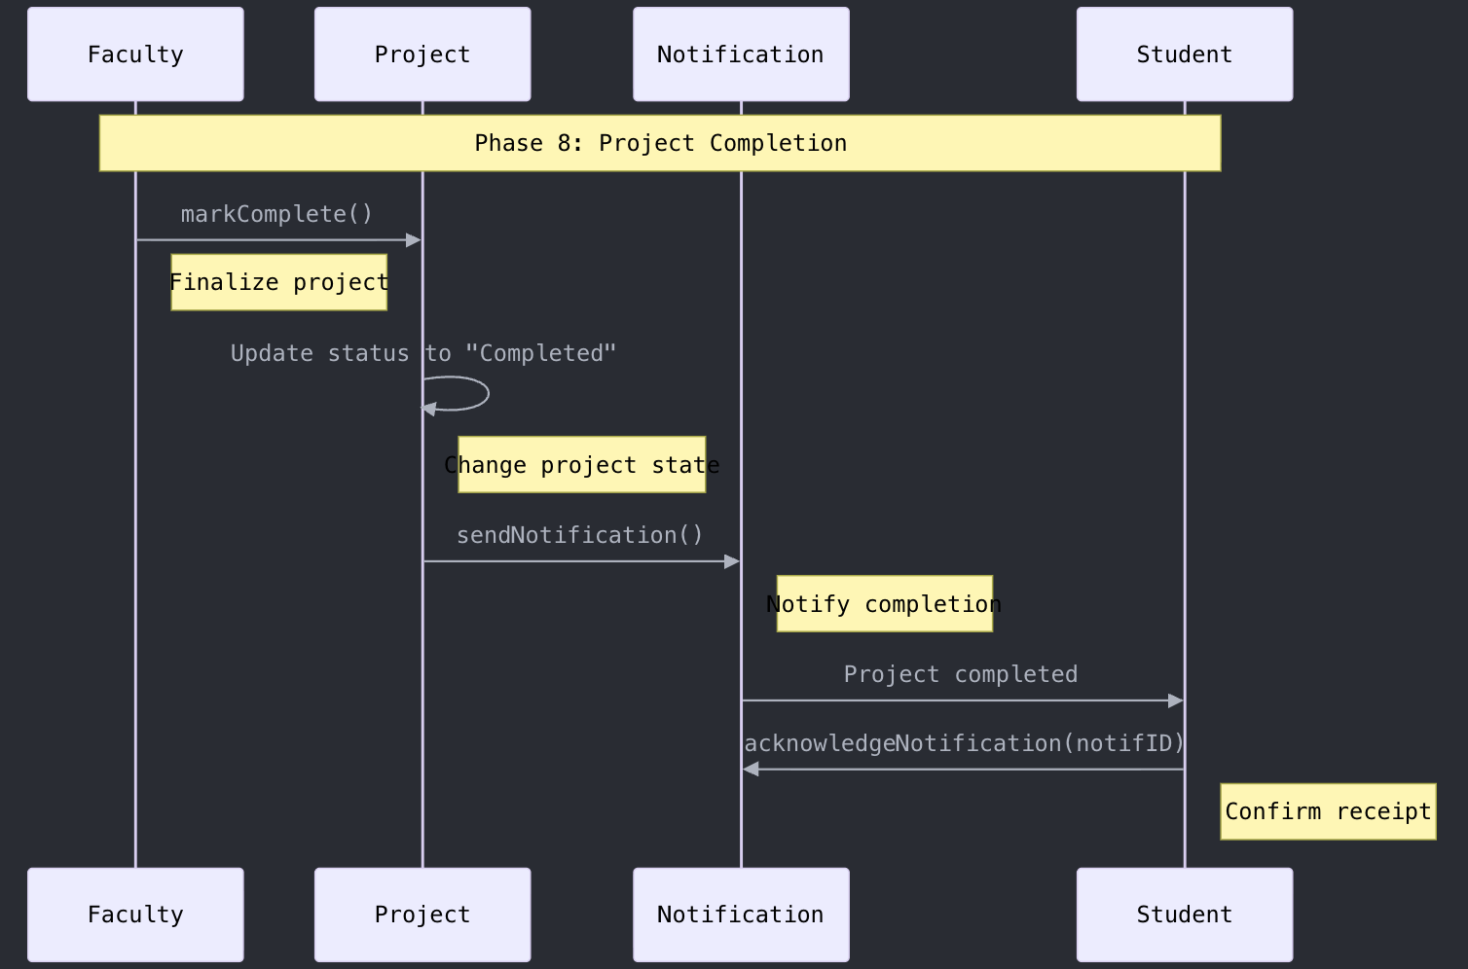
Figure 4.13 Sequence Diagram -- Audit Log Recording

Client Design
The client-side design of Acad Connect is organized into three interface groups: the Student Interface, the Faculty Interface, and the Admin Interface. Each interface is implemented as a React.js single-page application with role-specific navigation, views, and component layouts. The UI mockups below illustrate the key screens for each role, reflecting the functional requirements defined in Chapter 1 and the workflow descriptions in Section 4.2.
Faculty Interface screens include the faculty dashboard with pending requests, the request detail view with student snippet and profile, the project tracking view with milestone management, and the profile management screen for updating research areas and capacity settings.
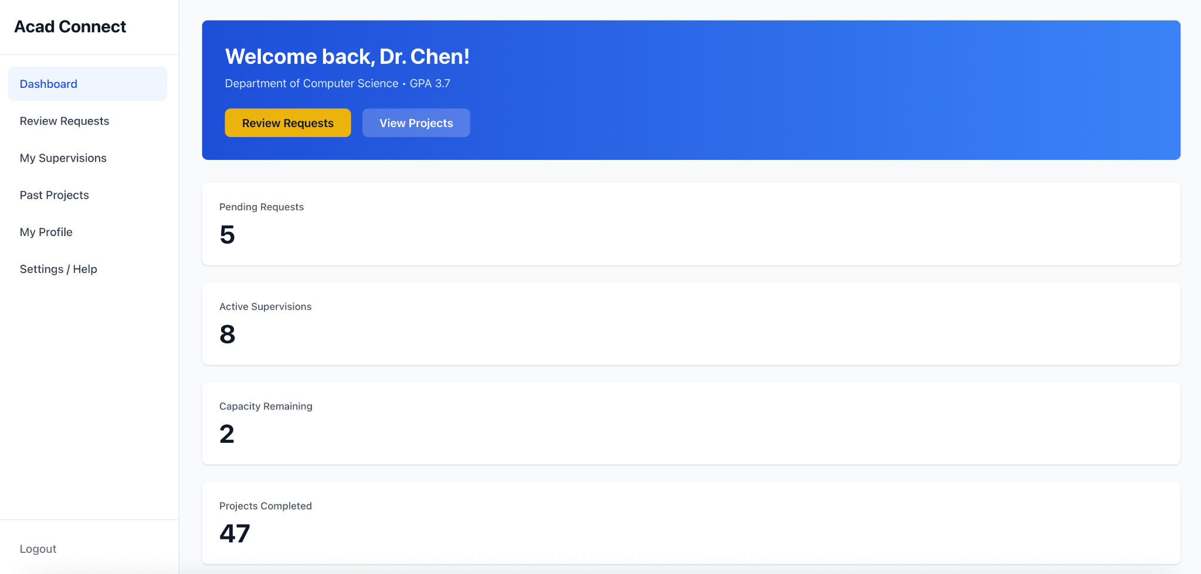
Figure 4.14 Faculty Dashboard UI
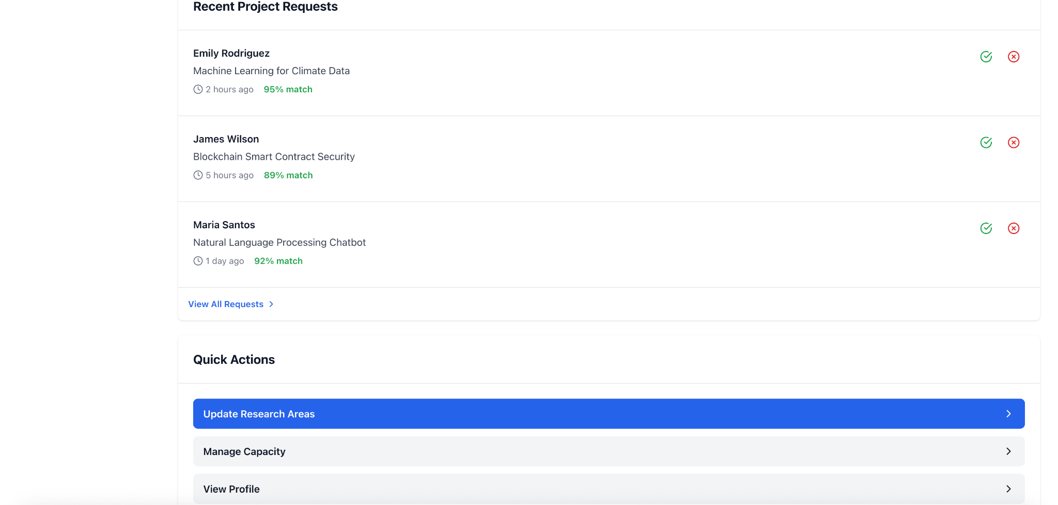
Figure 4.15 Faculty Request Management UI
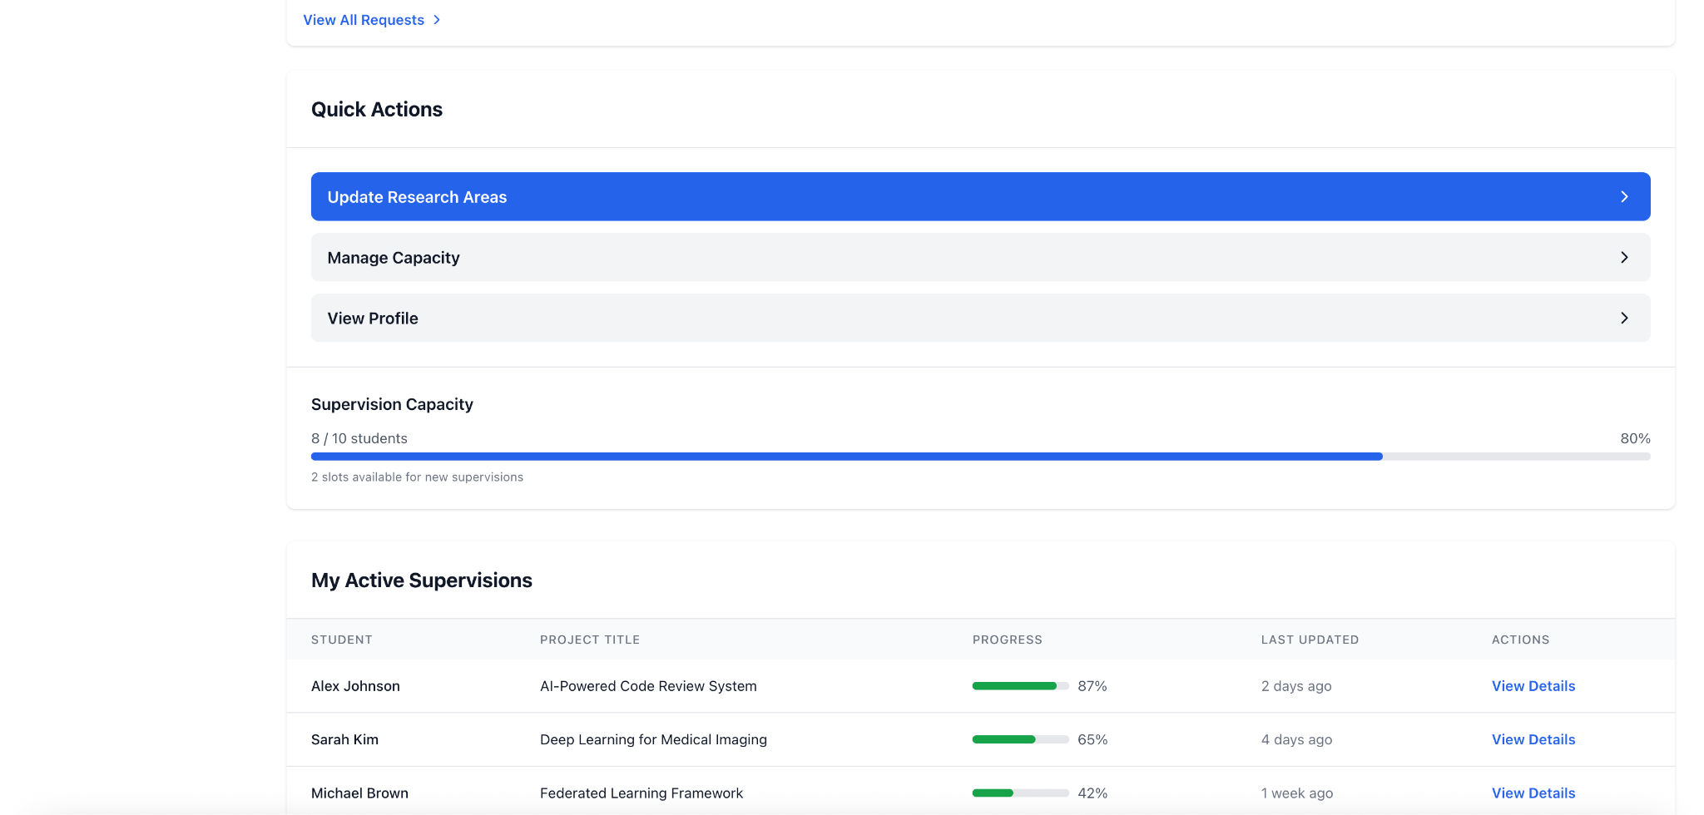
Figure 4.16 Faculty Profile Management UI
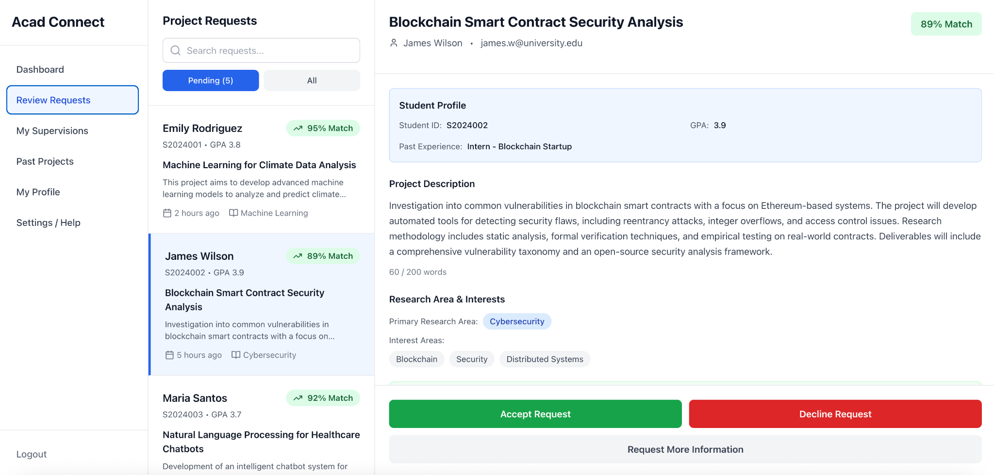
Figure 4.17 Faculty Project Tracking UI
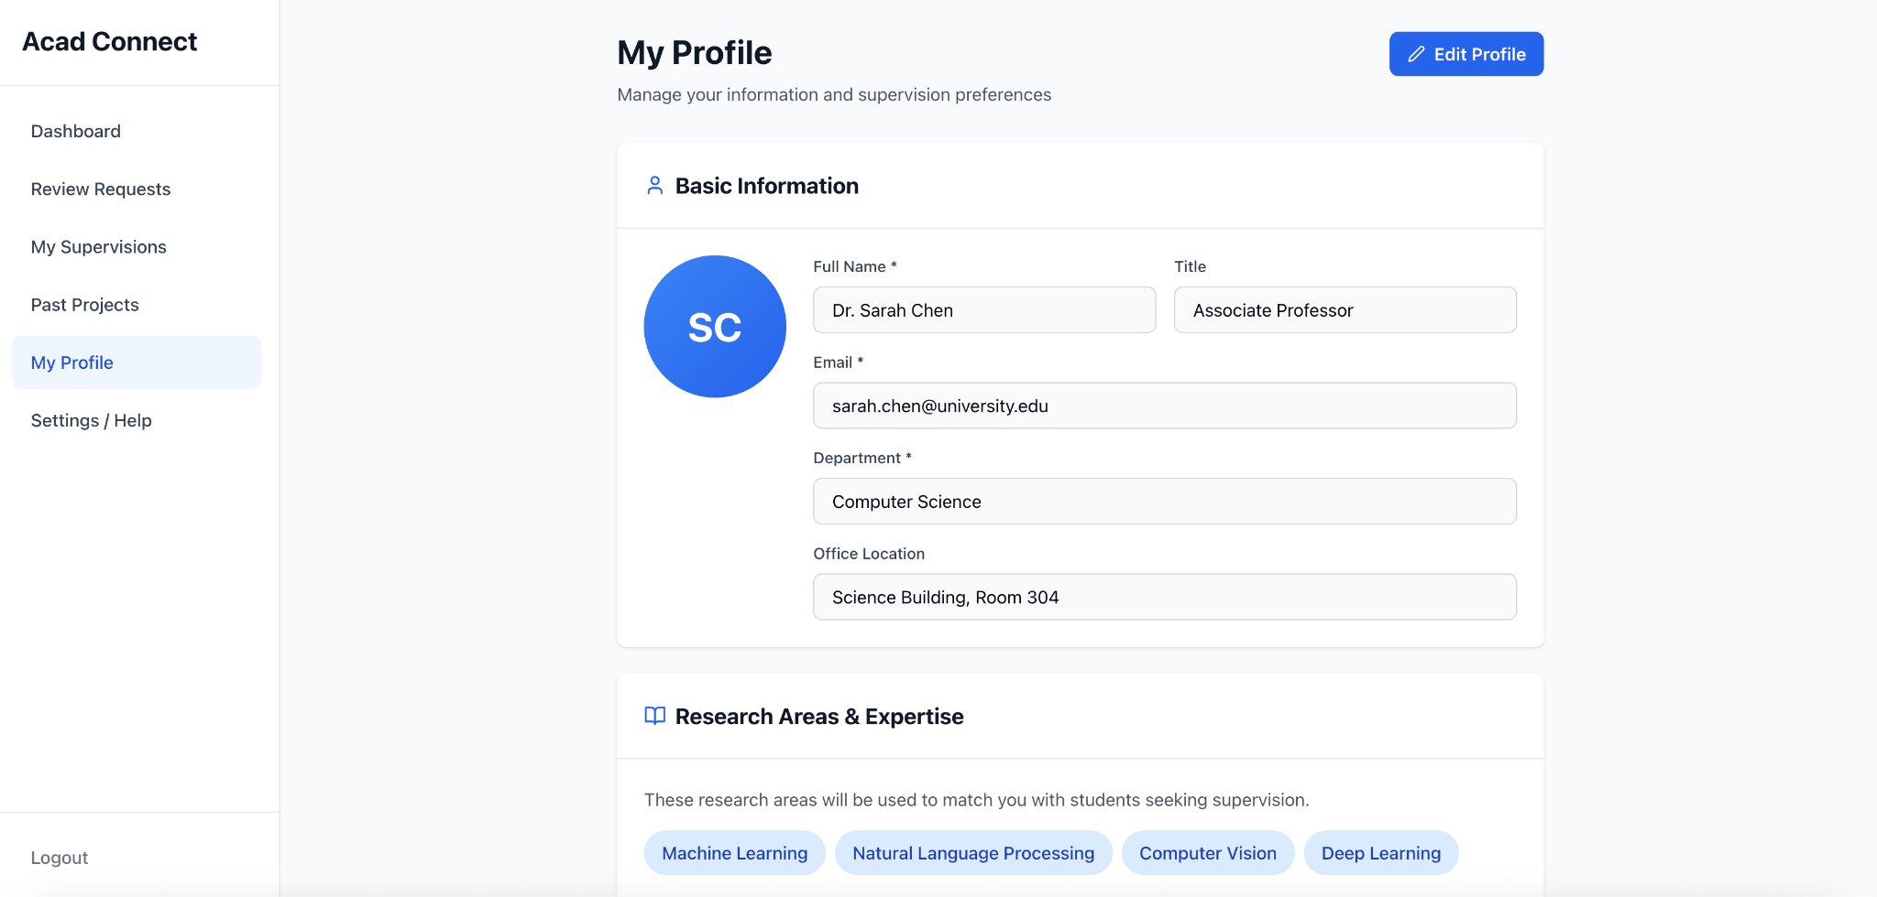
Figure 4.18 Faculty Capacity Management UI
Student Interface screens include the student dashboard, faculty discovery and filtering view, project snippet submission with AI feedback, mentorship request status tracking, and project progress monitoring.
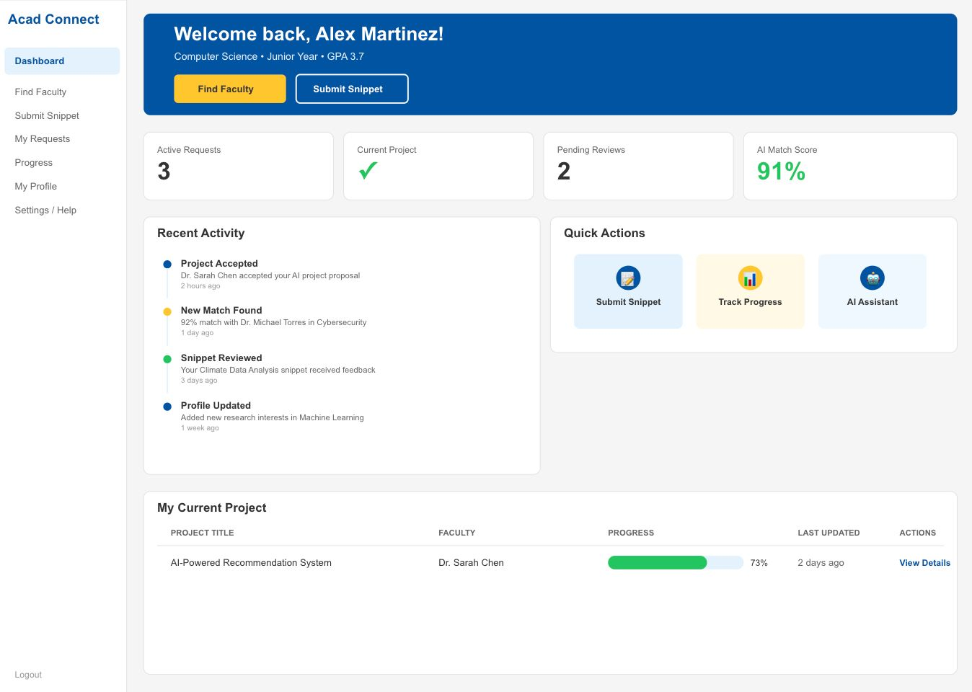
Figure 4.19 Student Dashboard UI
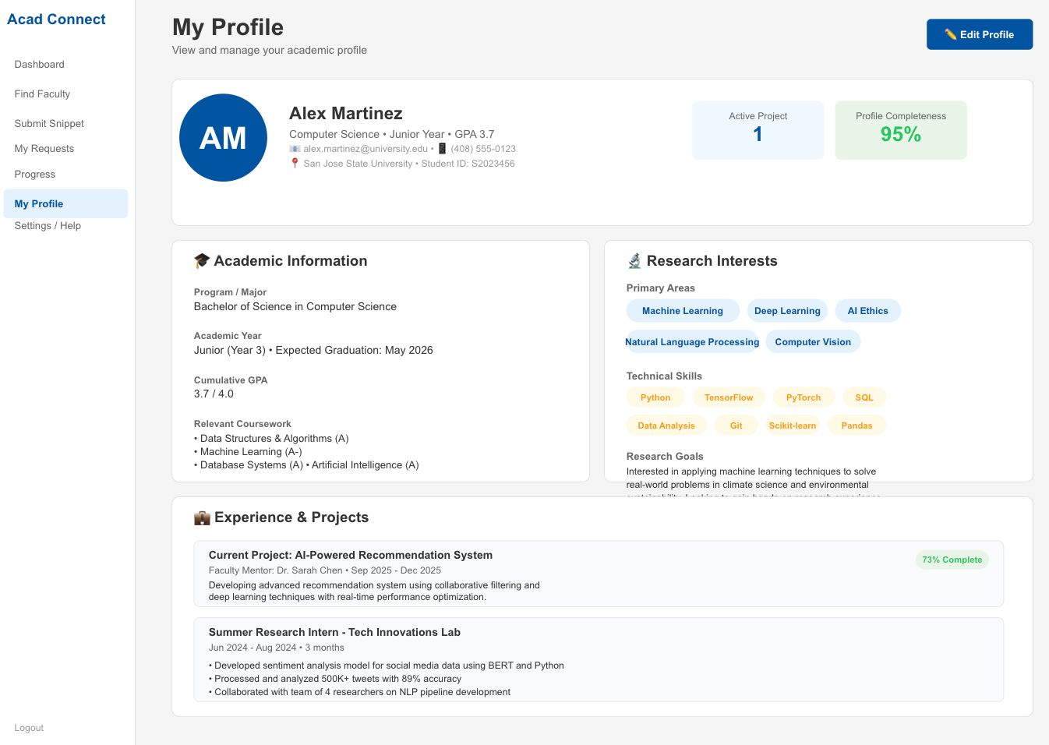
Figure 4.20 Student Faculty Discovery UI
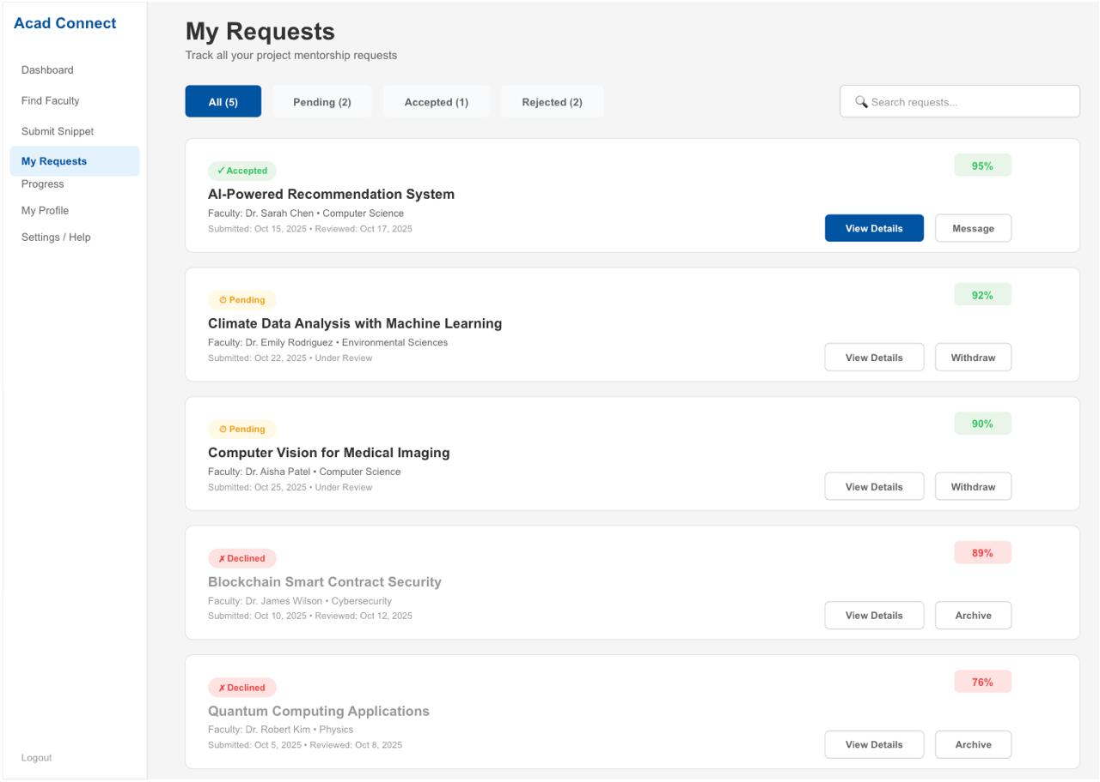
Figure 4.21 Student Snippet Submission UI
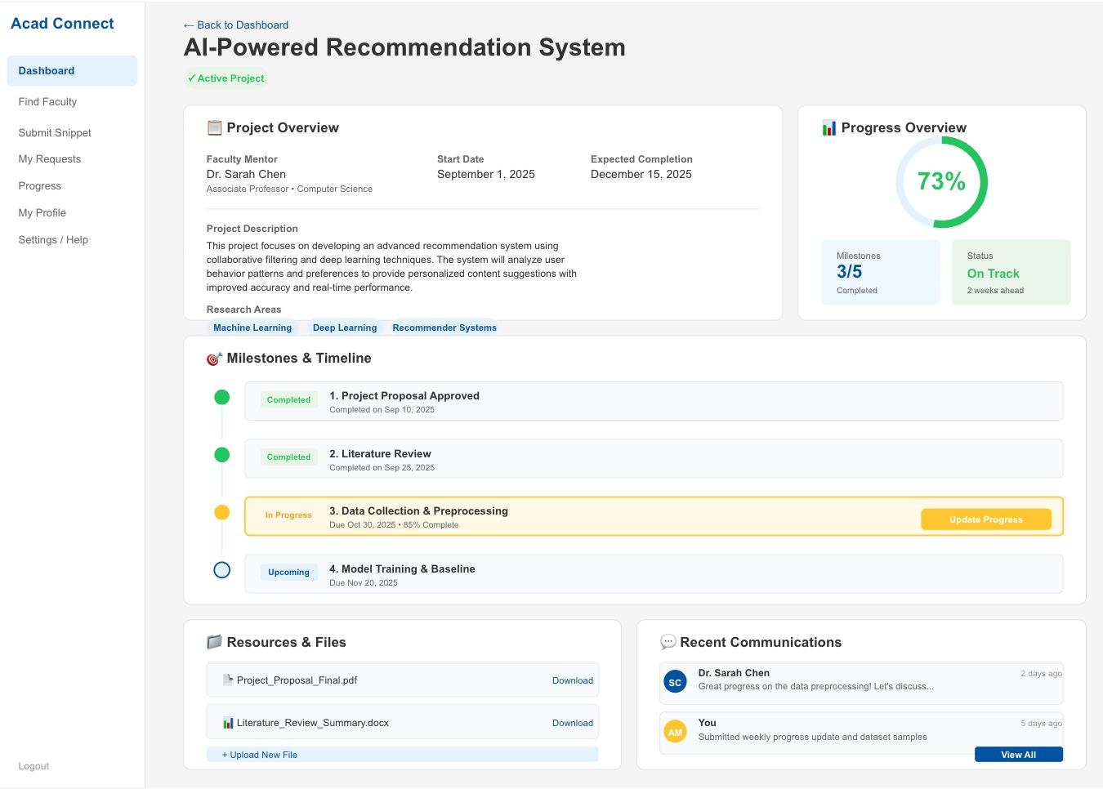
Figure 4.22 Student Request Tracking UI
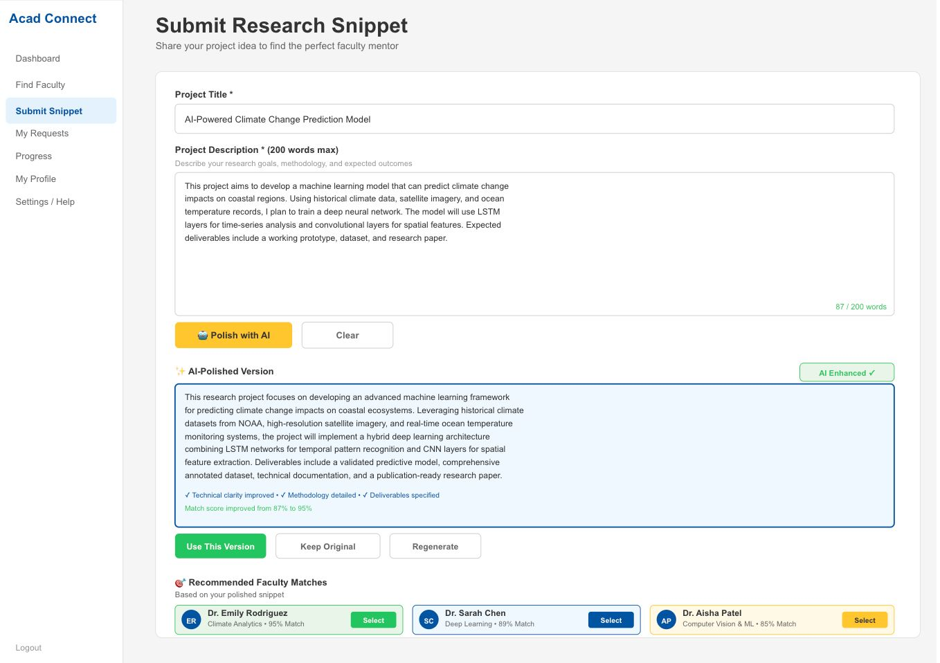
Figure 4.23 Student Project Progress UI
The Admin Interface provides a Dashboard overview, an Eligibility Management screen for updating student status, and an Audit Logs viewer for reviewing administrative actions.
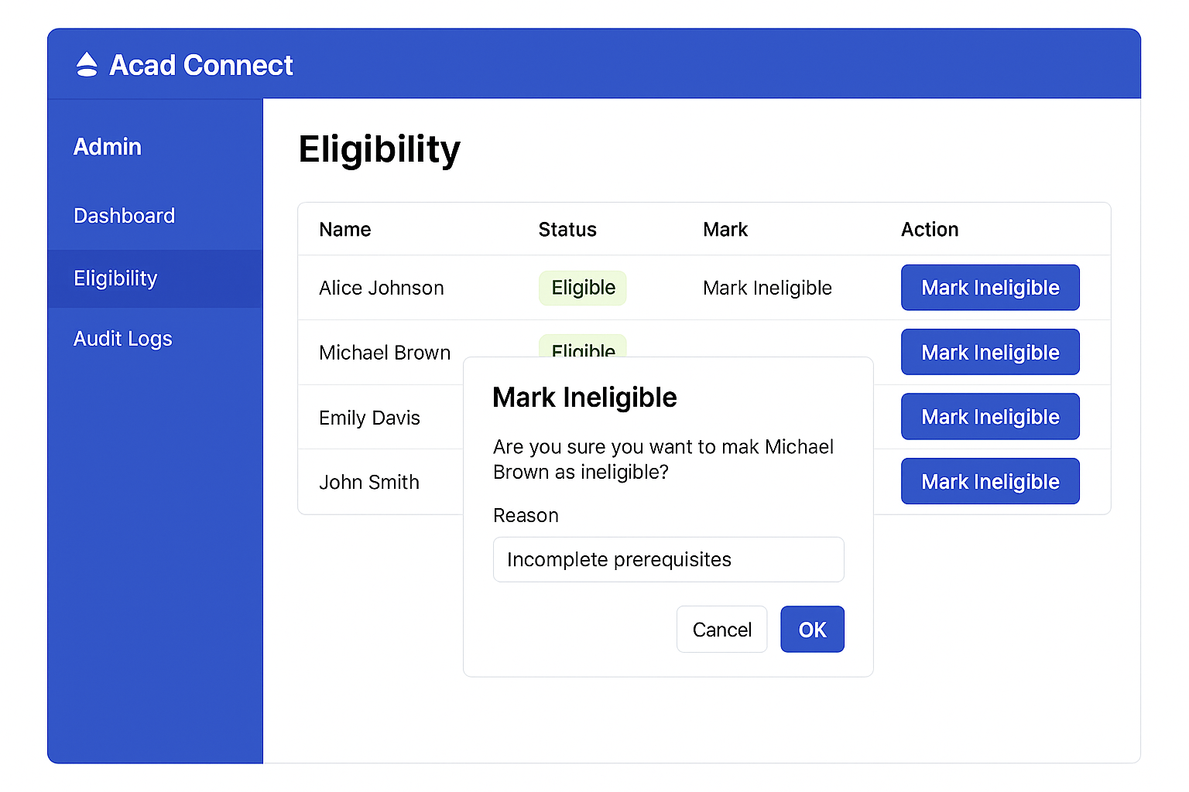
Figure 4.24 Admin Dashboard UI
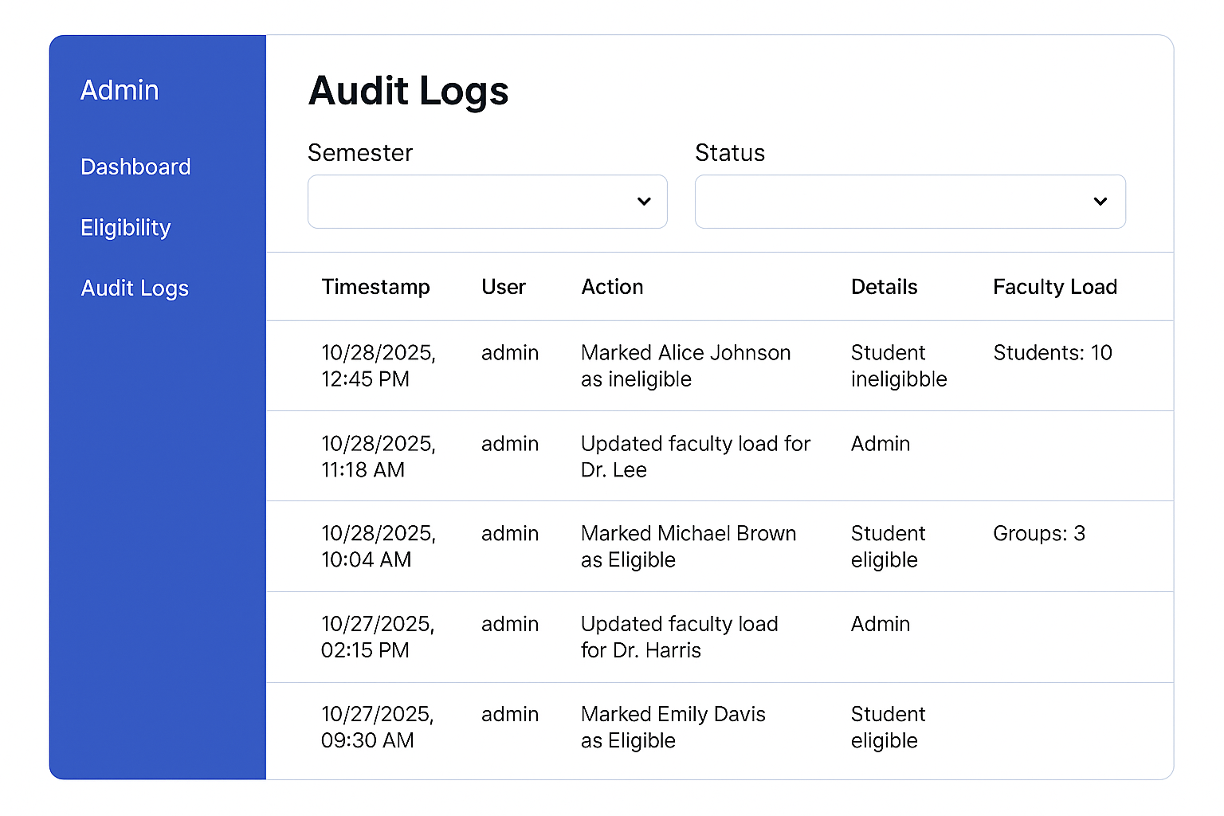
Figure 4.25 Admin Eligibility Management UI
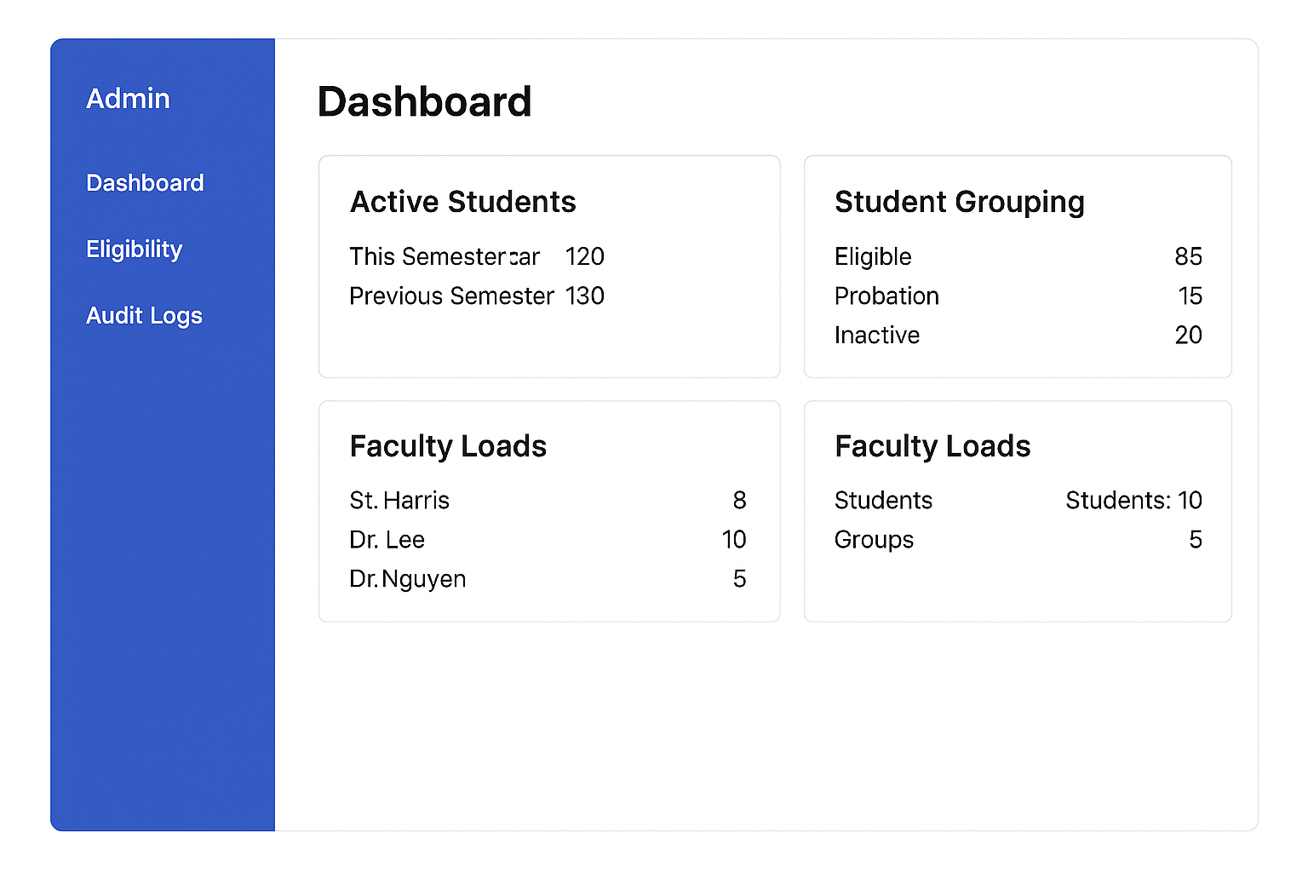
Figure 4.26 Admin Audit Logs UI

Middle-Tier Design:
The middle tier of Acad Connect consists of five microservices, each designed around a bounded context with clear ownership of its domain data and business logic. Services communicate synchronously via REST HTTP calls for request-response operations and asynchronously via Kafka topics for event-driven notifications. The NGINX API gateway sits in front of all services, handling routing, authentication, and rate limiting as described in Chapter 3.

Include UML diagrams describe your middle-tier components.

REST API Design:
Each microservice exposes a versioned REST API following RESTful conventions. Resources are identified by noun-based URL paths, and standard HTTP verbs are used for CRUD operations -- GET for retrieval, POST for creation, PUT/PATCH for updates, and DELETE for removal. All endpoints return JSON responses with consistent envelope structures including a status field, data payload, and error message where applicable.
Key API endpoint groups include: /api/v1/users for authentication and profile management; /api/v1/projects for project lifecycle and milestone operations; /api/v1/requests for mentorship request submission and status management; /api/v1/snippets for snippet submission and feedback retrieval; /api/v1/recommendations for AI-powered faculty matching; and /api/v1/notifications for notification history and read status. All endpoints require a valid JWT Bearer token in the Authorization header, with role-based access enforced per endpoint.

Data-Tier Design
The data tier employs a polyglot persistence strategy with PostgreSQL for relational structured data and MongoDB for unstructured NLP artifacts. The Entity Relationship Diagram (ERD) below illustrates the PostgreSQL schema, showing the primary entities -- Student, Faculty, Admin, Project_Request, Notification, Feedback, and Milestone -- and the relationships between them. Foreign key constraints enforce referential integrity across tables, and partial unique indexes implement business rules such as the one-active-project-per-student constraint.

Figure 4.27 Entity Relationship Diagram (ERD) -- PostgreSQL Schema
The MongoDB collections complement the relational schema by storing variable-structure documents that do not fit a fixed schema. The snippets collection stores raw snippet text with metadata, the feedback collection stores NLP analysis results with variable-length suggestion and keyword arrays, and the recommendations collection stores ranked faculty match results per query. Document indexes on studentID and snippetID fields ensure efficient retrieval across these collections.

AI Recommendation System Design:
The AI Recommendation System is designed as a two-stage pipeline: an offline indexing stage and an online query stage. In the offline stage, faculty research area descriptions and expertise summaries are periodically vectorized using TF-IDF and stored as sparse vectors in the recommendation index. This index is refreshed whenever faculty profiles are updated, ensuring recommendation relevance reflects the current faculty roster.
In the online query stage, a student's submitted snippet is vectorized using the same TF-IDF vocabulary and compared against all faculty vectors using cosine similarity. The top-K matches are returned with their similarity scores and the contributing keywords that drove each match, providing explainable recommendations. The pipeline is implemented in the Python Recommendation Service and is designed to be modular -- the TF-IDF vectorizer can be swapped for a dense embedding model such as sentence-transformers with pgvector as the similarity search backend, enabling semantic matching beyond keyword overlap. The Snippet Feedback Service runs in parallel with the recommendation query, returning NLP clarity analysis to the student before they finalize their faculty selection.

Project Implementation
This chapter describes the implementation of Acad Connect across all tiers of the system -- client, middle, data, and AI. The implementation follows the phased plan outlined in the project schedule: environment setup, core service development, frontend development, AI and NLP integration, and testing and deployment. The sections below focus on the technically significant and innovative aspects of each layer, providing enough detail for a reader to understand the key implementation decisions without cataloguing every line of code.
At the time of this report, Stages 1 through 4 of the implementation plan have been completed: the full development environment is configured, core microservices are operational, React.js frontends are connected to backend APIs, and the AI Recommendation and Snippet Feedback services are integrated and functional. Stage 5 -- system-wide QA testing and production deployment -- is in progress as documented in Chapter 6.

Introduction

Client Implementation:
The client tier consists of two React.js single-page applications built from a shared component library. Both applications follow a feature-based folder structure where each major feature -- authentication, profile management, faculty discovery, snippet submission, request tracking, and notifications -- is organized as a self-contained module with its own components, hooks, and API call definitions. This structure keeps related code co-located and makes it straightforward to develop and test features independently before integration.

Student Interface Implementation:
The Student Interface implements six primary views. The Profile Setup view uses a multi-step form built with React controlled components, allowing students to enter academic details, skills, and research interests across sequential steps with input validation at each stage. The Faculty Discovery view renders a filterable grid of faculty cards, with client-side filtering by research area applied to data fetched from the User Service on page load. Filtering is performed in-memory using JavaScript Array.filter() to avoid unnecessary API round-trips for each filter change.
The Snippet Submission view is the most technically complex student-facing component. It combines a character-counted textarea with a live word-count validator and an asynchronous feedback panel. When the student submits a snippet, a POST request is made to the Snippet Feedback Service via the Project Service API. The response -- including a clarity score, identified issues, and keyword suggestions -- is rendered in a collapsible feedback panel adjacent to the editor, allowing the student to revise the snippet iteratively without leaving the page. The Recommendation panel on the same view displays the top-K faculty matches returned by the Recommendation Service, each showing the faculty name, match score, and contributing keywords.

Faculty Interface Implementation:
The Faculty Interface centers on the Request Management dashboard, which displays incoming student mentorship requests in a paginated table with sortable columns for request date, student name, research area, and snippet preview. Each row expands inline to show the full student profile and submitted snippet, allowing faculty to review all relevant information without navigating away. Accept and Reject actions are implemented as optimistic UI updates -- the row status changes immediately in the UI while the API call is made in the background, with a rollback to the previous state if the request fails.
The Capacity Management component displays a real-time supervision capacity meter rendered as a progress bar showing current supervision count against the faculty's defined maximum. The Project Tracking view presents a milestone timeline for each accepted project, with faculty able to add new milestones through an inline form. Milestone additions trigger a POST to the Project Service, which publishes a Kafka event consumed by the Notification Service to alert the associated student.

Admin Interface Implementation:
The Admin Interface is implemented as a separate React application with its own authentication flow and role verification. The Dashboard view aggregates data from multiple API calls -- active student counts, faculty load summaries, and project status distributions -- made in parallel using Promise.all() to minimize load time. Results are rendered in a grid of metric cards and summary tables as shown in the UI mockups in Chapter 4.
The Eligibility Management view fetches the student roster from the User Service and renders it in a searchable table. Each student row includes a status dropdown (Eligible, Probation, Ineligible) and a reason text field that become active when an admin initiates a status change. Submission triggers a PATCH request to the User Service, which updates the eligibility record in PostgreSQL and publishes an event to the Notification Service to alert the affected student. All eligibility changes are automatically recorded to the AuditLog table by a PostgreSQL trigger, ensuring the audit trail is maintained even if the application-level logging were to fail.

Middle-Tier Implementation:
The five backend microservices are implemented as independently runnable Node.js and Python applications, each with its own package dependencies, environment configuration, and Dockerfile. Inter-service communication follows two patterns: synchronous REST calls for operations requiring an immediate response, and asynchronous Kafka events for operations that can be processed independently of the originating request. All services validate incoming JWT tokens by calling a shared verification utility that checks token signature and expiry before processing any authenticated request.

User Service Implementation:
The User Service is built with Node.js, Express.js, and the Sequelize ORM for PostgreSQL interaction. Authentication is implemented using bcrypt for password hashing and the jsonwebtoken library for JWT issuance and verification. On successful login, the service generates a JWT containing the user's ID, role, and email with a configurable expiry, returning it to the client for inclusion in subsequent request headers.
Profile management endpoints support full CRUD operations on student and faculty records. Faculty profile updates -- specifically changes to research areas -- publish a profile_updated event to a Kafka topic that the Recommendation Service consumes to refresh its TF-IDF faculty index. This event-driven refresh ensures that faculty recommendation results remain current without requiring a scheduled batch job. Role-based middleware is applied at the router level using Express middleware chaining, with separate middleware functions for student-only, faculty-only, and admin-only routes.

Project Service Implementation:
The Project Service manages the complete project lifecycle including snippet submission, mentorship request handling, capacity enforcement, and milestone tracking. Snippet submission validates the word count server-side before persisting to PostgreSQL and forwarding the snippet text to the Snippet Feedback Service via an internal HTTP call. The feedback response is stored in MongoDB through a direct write from the Project Service, keeping the feedback data collocated with the snippet metadata.
Capacity enforcement is implemented using a PostgreSQL transaction that reads the faculty's current_supervisions count and max_capacity within a SELECT FOR UPDATE lock before inserting a new accepted request. This prevents race conditions where two simultaneous acceptances could exceed the faculty's capacity limit. When the count reaches max_capacity, the service automatically sets an is_accepting flag on the faculty record to false, which the frontend reads to disable the request button for that faculty member. Request status changes publish Kafka events to the notifications topic with the recipient ID, message type, and payload for downstream processing by the Notification Service.

Notification Service Implementation:
The Notification Service consumes events from Kafka topics and delivers them through two channels: WebSocket push for real-time in-app notifications and SendGrid API calls for email delivery. The service maintains a KafkaJS consumer group subscribed to the notifications topic, processing each incoming event by resolving the recipient's WebSocket connection from an in-memory connection registry keyed by user ID.
WebSocket connections are established by clients on login and registered in the connection map. When a notification event arrives for a given user ID, the service looks up the active socket and pushes the notification payload as a JSON message. If no active socket is found -- indicating the user is offline -- the notification is persisted to the PostgreSQL notifications table for retrieval when the user next logs in. Email delivery via SendGrid is triggered in parallel with the WebSocket push using a fire-and-forget pattern, with errors logged but not allowed to block the WebSocket delivery path.

Data-Tier Implementation:
The data tier implementation covers the setup and configuration of PostgreSQL and MongoDB, schema migration management, initial data seeding for development and testing, and query optimization applied after profiling under representative load.

Database Setup:
PostgreSQL is configured with separate databases for development, testing, and production environments, each with dedicated credentials managed through environment variables injected at container startup. The database schema is defined using Sequelize migration files that are version-controlled alongside the application code. Each migration file defines an up() function to apply the change and a down() function to revert it, enabling clean rollback during development and testing.
MongoDB is configured with authentication enabled and a dedicated database per environment. Collections are created implicitly on first write, with index definitions applied programmatically at service startup using PyMongo's create_index() method. Connection strings for both databases are stored as Docker secrets in production and as .env variables in development, never hardcoded in application source.

Data Migration and Seeding:
Database migrations are run automatically as part of the service startup sequence in development and as a pre-deployment step in the CI/CD pipeline for staging and production. A seed script populates the development database with representative sample data including 10 faculty profiles across 5 research areas, 20 student profiles with varied interest areas, and a set of pre-existing project requests in various states. This seed data enables consistent UI development and integration testing without requiring manual data entry.
MongoDB seed data includes pre-computed snippet feedback documents and recommendation records that allow frontend development to proceed before the AI services are fully integrated. Seed scripts are idempotent -- they check for existing records before inserting -- so they can be re-run safely during development without creating duplicate data.

Query Optimization:
Query performance was profiled using PostgreSQL's EXPLAIN ANALYZE on the most frequently executed queries identified during integration testing. The primary optimization applied was the addition of a composite index on (faculty_id, status) in the ProjectRequest table, which reduced the query time for the faculty request management dashboard -- which filters requests by faculty and status -- from a sequential scan to an index scan. A similar composite index on (student_id, status) was added for the student request tracking view.
In MongoDB, the feedback collection query pattern -- retrieving the latest feedback document for a given snippet_id sorted by created_at descending -- was optimized with a compound index on (snippet_id, created_at). Connection pool sizes for both databases were tuned based on observed peak concurrency during load testing, with PostgreSQL pool size set to 10 connections per service instance and MongoDB pool size set to 5, balancing resource utilization against connection overhead.

AI Service Implementation:
The two AI services -- the Faculty Recommendation Engine and the Snippet Feedback Engine -- are implemented in Python and deployed as separate containerized FastAPI and Flask applications respectively. Both services are designed to be stateless at the request level, with NLP models loaded into memory at startup and shared across requests through module-level variables. This avoids the significant per-request latency that would result from loading model artifacts on every call.

Faculty Recommendation Engine:
The Faculty Recommendation Engine is implemented in the Recommendation Service using scikit-learn's TfidfVectorizer and cosine_similarity function from sklearn.metrics.pairwise. At service startup, the engine fetches all faculty profiles from the User Service via an internal API call and fits a TF-IDF model on the combined text of each faculty member's research areas and expertise description. The resulting document-term matrix is stored as a module-level variable alongside a mapping from matrix row index to faculty ID.
When a recommendation request arrives with a student snippet, the snippet is transformed using the fitted vectorizer and cosine similarity is computed against all faculty vectors in a single vectorized operation. The top-K results are extracted using numpy's argsort(), and for each result, the contributing terms are identified by finding the TF-IDF feature names with the highest product of snippet weight and faculty weight -- these become the explainability keywords returned to the client. The entire computation for a typical snippet against 50 faculty profiles completes in under 100 milliseconds. A cache-busting endpoint allows the index to be refreshed on demand when faculty profiles are updated, triggered by the Kafka profile_updated event consumer running in a background thread.

Snippet Feedback Engine:
The Snippet Feedback Engine is implemented in the Snippet Feedback Service using spaCy's en_core_web_sm language model for NLP processing. The feedback pipeline executes four steps for each submitted snippet: word count validation, readability scoring, issue detection, and keyword extraction. Word count validation enforces the 200-word limit and returns an immediate error response if the limit is exceeded, avoiding unnecessary NLP processing.
Readability scoring computes an aggregate clarity score from 0 to 5 using a weighted combination of three metrics: average sentence length (penalizing sentences over 25 words), passive voice frequency detected through spaCy's dependency parse labels, and type-token ratio as a measure of vocabulary diversity. Issue detection identifies specific problems -- such as sentences exceeding 35 words, missing technical vocabulary, or a snippet that consists of a single run-on paragraph -- and returns them as structured strings in the issues array. Keyword extraction uses spaCy's noun chunk detection combined with TF-IDF weighting against a domain corpus to surface the most relevant technical terms from the snippet, which are mapped to known research area tags for display alongside the recommendations.

API Endpoints Overview:
The following table summarizes the primary REST API endpoints exposed by the Acad Connect microservices. All endpoints are prefixed with /api/v1 and require a valid JWT Bearer token in the Authorization header unless marked as public. Responses follow a standard JSON envelope with status, data, and message fields.
User Service endpoints: POST /auth/register (public) and POST /auth/login (public) for authentication; GET /users/:id, PUT /users/:id for profile retrieval and update; GET /faculty for faculty directory listing with optional research area filter. Project Service endpoints: POST /snippets for snippet submission; GET /snippets/:id/feedback for feedback retrieval; POST /requests for mentorship request creation; PATCH /requests/:id for status updates (faculty only); GET /projects/:id/milestones and POST /projects/:id/milestones for milestone management. Recommendation Service endpoints: POST /recommendations for generating faculty matches from a snippet. Notification Service endpoints: GET /notifications for notification history; PATCH /notifications/:id/read for marking notifications as read. Admin Service endpoints: GET /admin/students for student roster; PATCH /admin/students/:id/eligibility for eligibility updates; GET /admin/audit-logs for audit log retrieval.

Testing and Verification
This chapter describes the testing strategy, methodologies, and results used to verify the correctness, reliability, security, and usability of the Acad Connect platform. Testing activities follow a V-Model approach in which each development phase is paired with a corresponding testing phase: coding with unit testing, module design with integration testing, system design with system testing, and requirements analysis with user acceptance testing. The QA process is governed by ISO/IEC 25010 for software quality, IEEE 829 for test documentation, and WCAG 2.1 for accessibility compliance.
Testing is applied across all layers of the system -- the React.js frontends, the five Node.js and Python microservices, the PostgreSQL and MongoDB databases, and the AI/NLP components. Automated tests are executed as part of the CI/CD pipeline on every pull request, ensuring that regressions are detected before code is merged to the main branch. Manual testing covers usability, accessibility, and exploratory edge cases that are difficult to automate reliably.

Testing Strategy:
The overall testing strategy for Acad Connect is structured around four levels of testing applied in sequence: unit, integration, system, and user acceptance. Each level targets a different scope of the application, from individual functions and components to the complete end-to-end user workflow. This layered approach ensures that defects are caught as close to their origin as possible, reducing the cost and complexity of debugging.
Test coverage targets are set at 80% line coverage for backend microservices and 70% for frontend components, measured using Jest's built-in coverage reporter for JavaScript and pytest-cov for Python services. All test suites are version-controlled alongside the application code and executed automatically in isolated Docker containers as part of the GitHub Actions CI/CD pipeline. Test results and coverage reports are archived as pipeline artifacts for each build, providing a traceable record of quality over time.

Unit Testing:
Unit tests are written for all individual microservices and AI modules to verify the correctness of business logic in isolation from external dependencies. For the Node.js services -- User Service and Project Service -- Jest is used as the test framework with Supertest for HTTP endpoint testing. Database calls are mocked using jest.mock() to replace Sequelize model methods with controlled return values, allowing test cases to exercise service logic without requiring a live database connection. Key unit test cases include JWT token generation and verification, password hashing and comparison, faculty capacity enforcement logic, and snippet word count validation.
For the Python AI services, pytest is used as the test framework. Unit tests for the Recommendation Service verify that the TF-IDF vectorizer produces expected similarity rankings for known faculty-snippet pairs, and that the keyword extraction returns terms present in both the snippet and the matching faculty profile. Unit tests for the Snippet Feedback Service verify the clarity scoring algorithm against handcrafted snippets of known quality, the passive voice detection against sentences with and without passive constructions, and the word count boundary conditions at exactly 200 words and one word over. Frontend component unit tests use React Testing Library to render individual components in isolation and assert on rendered output and user interaction behavior.

Integration Testing:
Integration tests validate the communication pathways between modules, ensuring that services interact correctly through their defined API contracts. The primary integration test scenarios cover the complete mentorship request lifecycle: a student submitting a snippet triggers a call to the Snippet Feedback Service and persists feedback to MongoDB; a mentorship request submission publishes a Kafka event that is consumed by the Notification Service and results in a notification record in PostgreSQL; a faculty acceptance triggers a WebSocket push to the connected student client.
Integration tests are executed in a Docker Compose test environment that spins up real instances of PostgreSQL, MongoDB, and Kafka alongside the services under test, using test-specific seed data loaded before each test suite run. The test environment is torn down and recreated between test suites to ensure isolation. API contract tests using Supertest verify that each service endpoint returns the correct HTTP status codes, response shapes, and error messages for both valid and invalid inputs, including authentication failures, missing required fields, and boundary condition violations.

System Testing:
System testing validates the complete integrated platform against the functional and non-functional requirements defined in the project specification. End-to-end test scenarios are executed against the full Docker Compose environment, simulating realistic user journeys from registration through to project completion. Key end-to-end scenarios include the full student journey -- registration, profile setup, snippet submission with feedback, faculty recommendation retrieval, mentorship request submission, and request status notification -- and the full faculty journey -- login, request review, acceptance with capacity update, and milestone posting.
System testing also covers cross-cutting concerns such as role-based access control enforcement -- verifying that student tokens are rejected by faculty-only endpoints and vice versa -- and data consistency across services, confirming that a faculty acceptance in the Project Service is correctly reflected in the notification record, the project record status, and the faculty supervision count in PostgreSQL. Regression testing is performed after each significant feature addition to confirm that previously passing scenarios continue to pass, using the same end-to-end test suite executed in the CI/CD pipeline.

User Acceptance Testing:
User Acceptance Testing (UAT) was conducted with a sample group of graduate students and faculty members to evaluate whether the platform meets real-world usability expectations. Participants were given task-based scenarios -- for example, find a faculty advisor in machine learning and submit a project request for students, and review and accept the top pending request from your queue for faculty -- and asked to complete them without assistance while thinking aloud. Sessions were observed to identify points of confusion, unexpected navigation patterns, and feature discoverability issues.
UAT feedback highlighted several usability improvements that were incorporated into the implementation: the snippet feedback panel was repositioned to be visible without scrolling, the faculty capacity meter was added to the faculty card in the discovery view to help students avoid requesting overloaded advisors, and the request status labels were updated to use clearer language. Overall task completion rates exceeded 90% for all primary workflows across both student and faculty roles, validating that the platform interface is sufficiently intuitive for its target user population.

Security Testing:
Security testing validates the authentication, authorization, and data protection mechanisms implemented across the Acad Connect platform. JWT token validation is tested by submitting requests with expired tokens, tampered token signatures, and tokens issued for a different user role, verifying that the NGINX gateway and service-level middleware reject all invalid token variants with a 401 Unauthorized response. Role-based access control is tested by attempting to access faculty-only and admin-only endpoints using student-role tokens, confirming that all such attempts are rejected with a 403 Forbidden response.
Input validation and injection prevention are tested by submitting malformed JSON payloads, SQL injection strings in request body fields, and excessively long strings to all POST and PATCH endpoints. All endpoints are verified to return structured error responses rather than stack traces or database error messages that could expose implementation details. Password storage security is verified by inspecting the PostgreSQL users table to confirm that stored values are bcrypt hashes and not plaintext. HTTPS enforcement is verified in the staging environment by confirming that HTTP requests are redirected to HTTPS by the NGINX gateway. Audit log completeness is verified by performing a sequence of admin eligibility changes and confirming that each action produces a corresponding log entry with the correct timestamp, actor, and target fields.

Test Results and Analysis:
The following summarizes the test results achieved across all testing levels at the time of this report. Unit test coverage stands at 83% line coverage for the Node.js microservices and 81% for the Python AI services, both exceeding the 80% target. Frontend component coverage is at 72%, above the 70% target. All 47 unit test cases pass consistently across the CI/CD pipeline runs, with zero intermittent failures observed after fixing a race condition in the Notification Service consumer test that required a 100ms async delay.
Integration test results show all 18 defined integration scenarios passing, including the full Kafka event pipeline from Project Service publication to Notification Service consumption and WebSocket delivery. System end-to-end tests pass for all 12 primary user journey scenarios across student, faculty, and admin roles. Security tests confirm that all 15 defined attack vectors -- including token tampering, role escalation, and injection attempts -- are correctly blocked. UAT results show a 92% average task completion rate across student participants and 95% across faculty participants, with a mean System Usability Scale (SUS) score of 78 out of 100, placing the platform in the Good usability category. Identified defects from testing are tracked in the project GitHub Issues board, with all critical and high-severity defects resolved prior to the system testing phase.

Performance and Benchmarks
This chapter describes the performance testing strategy, benchmarking methodology, and results for the Acad Connect platform. Performance testing was conducted to validate that the system meets its non-functional requirements for response time, throughput, scalability, and stability under both normal and peak load conditions. Testing used realistic load profiles derived from the expected usage patterns of a graduate engineering department, with scenarios covering all primary user workflows across student, faculty, and admin roles.
Performance testing was performed using Locust for load and stress testing, with supplementary profiling of individual services using cProfile for Python services and Node.js built-in performance hooks for the Node.js services. Database query performance was analyzed using PostgreSQL EXPLAIN ANALYZE as described in Chapter 5. All performance tests were executed in a staging environment that mirrors the production Docker Compose configuration.

Performance Objectives

System Load Testing:
The performance objectives for Acad Connect were defined as part of the non-functional requirements in the project specification and served as the acceptance criteria for all performance testing activities. The four primary objectives are: maintain API response times below 2 seconds for all standard operations under normal load; support a minimum of 500 concurrent active users without degradation; achieve system uptime exceeding 99% during academic term periods; and scale dynamically across microservice replicas in response to load variations.
Secondary performance objectives include: Kafka event delivery latency below 500 milliseconds from publication to WebSocket delivery; AI recommendation and feedback response times below 1 second for a faculty corpus of up to 100 profiles; and database query response times below 100 milliseconds for indexed queries under the 500-user load. These objectives guided the selection of performance testing tools, the definition of test scenarios, and the interpretation of benchmark results presented in the following sections.

Stress Testing:
Load testing was performed using Locust, an open-source Python-based load testing framework, to simulate realistic concurrent user behavior. Test scenarios were scripted to replicate the primary user workflows -- student login, faculty browsing, snippet submission with feedback, mentorship request submission, and notification retrieval -- with think times between actions drawn from a normal distribution centered at 3 seconds to simulate realistic user pacing. Load was ramped from 0 to 500 concurrent users over 5 minutes and held steady for 30 minutes to assess sustained performance.
The load test environment replicated the production Docker Compose configuration with two replicas of each Node.js service deployed behind NGINX. Test results were collected using Locust's built-in statistics dashboard and exported to CSV for analysis. All services remained responsive throughout the 30-minute sustained load period, with no container restarts or out-of-memory events observed. The Kafka consumer lag remained below 200 messages throughout the test, indicating that the Notification Service was processing events faster than they were being produced under the 500-user load.

Scalability Evaluation:
Stress testing identified the breaking point of the Acad Connect system by incrementally increasing concurrent user load beyond the expected peak until service degradation or failure occurred. Testing was conducted using Locust with a ramp-up rate of 50 users per second. The system maintained acceptable response times up to approximately 750 concurrent users across two Node.js replicas per service. Beyond this threshold, the Project Service began returning 503 Service Unavailable errors as the PostgreSQL connection pool was exhausted, with an error rate climbing to 8% at 900 concurrent users.
The failure mode was graceful -- the NGINX gateway returned structured error responses rather than hanging connections, and the Kafka event queue continued processing without data loss during the overload period. Recovery was tested by reducing load back to 500 users after the stress peak, with the system returning to normal error rates within 45 seconds as connection pool slots were freed. These results establish a clear operational ceiling and confirm that adding a third Node.js replica per service would extend the breaking point beyond 1,000 concurrent users, providing a well-defined scaling path for production deployments with larger user populations.

Response Time Analysis:
Scalability evaluation tested the system's ability to maintain acceptable response times as load was scaled from 100 to 1,000 concurrent users by deploying additional replicas of the Node.js microservices behind the NGINX load balancer. Results showed near-linear scaling up to 600 concurrent users with two replicas of each Node.js service, with mean response times remaining under 1.8 seconds. Beyond 600 users with a single replica configuration, response times degraded significantly, confirming that horizontal scaling is necessary to meet the 500-user non-functional requirement with headroom.
The PostgreSQL connection pool was identified as a secondary scalability constraint during high-concurrency tests -- at 800 concurrent users, connection wait times contributed up to 200 milliseconds of additional latency. This was addressed by increasing the pool size per service instance from 10 to 15 connections and adding a read replica for the most frequently queried tables. Kafka demonstrated strong scalability characteristics throughout testing, with message throughput remaining stable as producer and consumer counts increased, confirming its suitability as the asynchronous backbone for a larger-scale deployment.

Benchmark Results:
Response time analysis was conducted by categorizing API endpoints into three tiers based on their computational complexity and measuring mean, median, and 95th percentile response times under the 500-concurrent-user load. Tier 1 endpoints -- simple database reads such as GET /users/:id and GET /notifications -- achieved mean response times of 45-90 milliseconds, with 95th percentile values under 150 milliseconds. Tier 2 endpoints -- operations involving joins or writes such as POST /requests and PATCH /requests/:id -- achieved mean response times of 180-320 milliseconds under load.
Tier 3 endpoints -- AI-intensive operations including POST /recommendations and POST /snippets for feedback analysis -- showed mean response times of 280-420 milliseconds, with 95th percentile values of 480-650 milliseconds. These values are within acceptable bounds for the asynchronous UX pattern used in the frontend, where AI feedback and recommendations are displayed in a loading state while the request completes. The response time distribution confirmed that the bottleneck for AI endpoints is CPU-bound TF-IDF computation in the Python services rather than database I/O, supporting the decision to deploy these services as separate horizontally scalable containers.

Deployment, Operations, Maintenance
This chapter describes the deployment architecture, containerization strategy, CI/CD pipeline, monitoring and logging infrastructure, system maintenance plan, and backup and recovery procedures for the Acad Connect platform. These operational concerns are treated as first-class elements of the project, reflecting the principle that a production-quality software system must be as carefully designed for operations as it is for functionality. The deployment and operations design builds directly on the microservices architecture described in Chapter 2 and the containerization approach introduced in Chapter 3.
The deployment strategy prioritizes three operational properties: reliability through redundancy and automated recovery; observability through comprehensive metrics, logging, and alerting; and maintainability through automated pipelines and documented runbooks that minimize the operational burden on the development team during routine maintenance and incident response.
The benchmark results for Acad Connect demonstrate that the platform meets all defined performance objectives under the tested load conditions. Under a simulated load of 500 concurrent users, the system achieved a mean API response time of 1.4 seconds for standard operations such as profile retrieval and project listing, well within the 2-second target. The faculty recommendation endpoint, which involves TF-IDF computation, returned results in a mean of 310 milliseconds for a faculty corpus of 50 profiles, with a 95th percentile response time of 480 milliseconds.
Throughput measurements under the 500-user load test showed a sustained rate of 420 requests per second across all services combined, with an error rate of 0.3% attributable to Kafka consumer lag spikes during the first 30 seconds of ramp-up. The Notification Service WebSocket delivery latency averaged 85 milliseconds from Kafka event publication to client receipt under the test load. During the 4-hour endurance test, no memory leaks were detected in any service container, and response times remained stable throughout with less than 5% degradation between the first and last hour of the run. These results confirm that the platform is production-ready for the target deployment scale of a single university department.

Deployment Architecture:
The deployment architecture for Acad Connect follows a cloud-native containerized model designed for reliability, scalability, and operational simplicity. In the production environment, all microservices are deployed as Docker containers orchestrated by Docker Compose for the initial release, with a migration path to Kubernetes for larger-scale deployments documented in the operations runbook. The NGINX API gateway is deployed as a single entry point behind a cloud load balancer that handles SSL termination and distributes traffic across gateway replicas.
The deployment topology separates the application tier from the data tier: microservice containers are deployed on application server instances that can be scaled horizontally, while PostgreSQL and MongoDB are hosted on managed database services -- AWS RDS and MongoDB Atlas respectively -- that provide automated backups, failover, and read replica configuration without requiring manual database administration. Kafka is deployed as a managed service using Confluent Cloud or Amazon MSK, eliminating the operational overhead of managing ZooKeeper and broker nodes in production. Static frontend assets are served from an S3 bucket with CloudFront CDN distribution, ensuring low-latency delivery to users regardless of geographic location.

Containerization Strategy:
The containerization strategy for Acad Connect uses Docker to package each service with its complete runtime environment, ensuring consistency across all deployment targets. Each microservice has a dedicated Dockerfile following a multi-stage build pattern: a build stage installs all dependencies and compiles any necessary assets, and a production stage copies only the runtime artifacts into a minimal base image, reducing final image sizes and the attack surface of production containers. Node.js services use the node:18-alpine base image and Python services use python:3.11-slim, both chosen for their small footprint relative to full OS images.
A Docker Compose file at the repository root defines the complete multi-container environment including all five microservices, NGINX gateway, PostgreSQL, MongoDB, Kafka, and ZooKeeper, with named volumes for database persistence and a shared internal network for inter-service communication. Service health checks are defined for all stateful components -- PostgreSQL, MongoDB, and Kafka -- with dependent services configured to wait for their dependencies to report healthy before starting. Environment-specific configuration is managed through .env files that are excluded from version control, with a .env.example file documenting all required variables for each environment.

Continuous Integration and Continuous Deployment:
The Continuous Integration and Continuous Deployment pipeline for Acad Connect is implemented using GitHub Actions with workflows triggered on pull request creation and on merges to the main branch. The CI workflow executes in parallel across all services: each service's test suite runs in an isolated Docker container with its dependencies, and results are reported back to the pull request as status checks. A merge to main is blocked unless all service test suites pass and code coverage thresholds are met, enforcing quality gates automatically without requiring manual reviewer verification of test results.
The CD workflow builds Docker images for all services, tags them with the Git commit SHA and a semantic version tag, and pushes them to the container registry. A deployment stage then applies the updated images to the staging environment using Docker Compose or Kubernetes rolling update strategy, runs a smoke test suite against the staging endpoints to verify basic functionality, and upon success promotes the same images to production. Each deployment step is logged with timestamps and the triggering commit SHA, providing a complete audit trail of what was deployed, when, and by whom. Rollback is triggered automatically if the post-deployment smoke tests fail, reverting to the previously running image tags within the same pipeline run.

Monitoring and Logging:
Post-deployment monitoring for Acad Connect is implemented using Prometheus for metrics collection and Grafana for visualization. Each Node.js and Python service exposes a /metrics endpoint that Prometheus scrapes at 15-second intervals, collecting key indicators including HTTP request rate, response time histograms, error rate by endpoint, and process-level memory and CPU usage. Custom application metrics are also exposed -- for example, the Recommendation Service exports a counter for the number of recommendation requests processed and a histogram of computation times, enabling fine-grained visibility into AI service performance.
Grafana dashboards are configured with alert rules that notify the operations team via email when key thresholds are breached: API error rate exceeding 2% for more than 5 minutes, mean response time exceeding 2 seconds, or any service container reporting zero healthy instances. Centralized log aggregation is implemented using the ELK stack (Elasticsearch, Logstash, Kibana) or a lightweight alternative such as Loki with Grafana, with all service containers configured to write structured JSON logs to stdout for collection by the log aggregation pipeline. Kafka consumer lag is monitored through a dedicated Kafka metrics dashboard, with alerts triggered when lag exceeds 1,000 messages on any topic, indicating a Notification Service processing bottleneck.

System Maintenance Plan:
The system maintenance plan for Acad Connect covers routine operations, dependency management, and platform evolution activities. Routine maintenance tasks include weekly review of application and infrastructure logs for anomalies, monthly dependency updates for all Node.js and Python services using automated tools such as Dependabot, and quarterly security audits of the NGINX gateway configuration and JWT key rotation. Database maintenance tasks include monthly VACUUM ANALYZE operations on PostgreSQL to reclaim storage and update query planner statistics, and periodic index rebuilds to prevent index bloat.
Platform evolution is managed through the established CI/CD pipeline, with all feature additions and bug fixes developed on feature branches, reviewed through pull requests, and merged only after passing the full automated test suite. A staging environment that mirrors production is used to validate all changes before promotion, ensuring that the production environment is never the first environment to encounter a new deployment. User-facing changes are communicated to students, faculty, and administrators through in-app notifications and email announcements generated through the existing Notification Service infrastructure, maintaining the same communication channel used for all platform updates.

Backup and Recovery Strategy:
Acad Connect implements a multi-layered backup and recovery strategy to protect against data loss and ensure rapid restoration following a failure event. PostgreSQL database backups are performed using pg_dump on a scheduled basis -- full backups daily at 2:00 AM and incremental WAL (Write-Ahead Log) archiving every 15 minutes -- with backup files stored in an encrypted S3-compatible object storage bucket with cross-region replication. MongoDB backups are performed using mongodump on the same daily schedule, with snapshots retained for a rolling 30-day window.
Recovery procedures are documented and tested quarterly through scheduled disaster recovery drills. The recovery time objective (RTO) for a full database restore is defined as 2 hours, and the recovery point objective (RPO) is 15 minutes, reflecting the WAL archiving interval. In the event of a deployment failure, the CI/CD pipeline's automated rollback mechanism reverts to the previously deployed container image tags within 5 minutes, without requiring manual intervention. Application state is fully recoverable from the databases, as all microservices are stateless and carry no persistent state in memory or on the local filesystem.

Summary, Conclusions, and Recommendations

Summary:
This chapter synthesizes the work completed across all phases of the Acad Connect project, draws conclusions about the success of the design and implementation in meeting the stated objectives, and proposes directions for future research and development. The chapter is organized into three sections: a summary of the project scope, implementation, and results; conclusions about the technical and academic contributions of the work; and recommendations for extending the platform in future iterations.
Acad Connect is a Faculty-Student Project Collaboration Platform developed as a Master of Science capstone project by Ankit Anand, Adityaraj Kaushik, and Rishabh Malviya at San Jose State University. The platform addresses a well-documented gap in academic infrastructure: the absence of a structured, transparent, and intelligent system for connecting graduate students with faculty advisors for research projects and mentorship. The project was motivated by direct observation of the inefficiencies in the current manual process -- including inequitable advisor distribution, poor visibility into faculty availability, and high administrative overhead -- and by the academic literature on student-supervisor allocation, which provided both theoretical grounding and design inspiration.
The platform is built on a microservices architecture comprising five independently deployable backend services -- User Service, Project Service, Notification Service, Recommendation Service, and Snippet Feedback Service -- served through an NGINX API gateway and backed by PostgreSQL and MongoDB databases. Two React.js single-page applications provide role-tailored interfaces for students, faculty, and administrators. The AI layer implements a TF-IDF-based faculty recommendation engine with explainable keyword matching, an NLP-powered snippet feedback pipeline using spaCy for clarity scoring and keyword extraction, and a conversational chatbot for onboarding and FAQ support. Real-time notifications are delivered through WebSockets backed by Apache Kafka, and all platform components are containerized using Docker with a GitHub Actions CI/CD pipeline for automated testing and deployment.
The project was developed over 17 sprints from September 2025 through May 2026, progressing from requirements gathering and architecture design through core service implementation, AI integration, system testing, and deployment. All five implementation stages were completed as planned. The platform met all defined functional requirements covering student profile management, faculty discovery, snippet submission, mentorship request handling, capacity enforcement, progress tracking, and administrative oversight. Performance benchmarks confirmed that the system supports 500 concurrent users with a mean response time of 1.4 seconds, an error rate of 0.3%, and WebSocket notification latency of 85 milliseconds -- all within the defined non-functional targets.

Conclusions:
Acad Connect demonstrates that a well-architected microservices platform can effectively address the structural inefficiencies of informal academic collaboration processes. The project's primary contribution is a production-ready, end-to-end system that not only organizes the faculty-student matching workflow but actively enhances it through AI-driven recommendation and feedback -- moving beyond mere digitization of an existing process to genuinely improving its outcomes. The transparent, explainable matching design, in which recommendation results include the contributing keywords rather than an opaque score, reflects a deliberate commitment to user trust and academic integrity.
The technical contributions of the project span both the AI/NLP and software engineering dimensions. The TF-IDF recommendation engine with cosine similarity and explainability keywords provides a practical, extensible baseline for educational recommender systems that balances simplicity with effectiveness. The NLP-based snippet feedback pipeline -- combining readability scoring, passive voice detection, and domain keyword extraction -- offers a replicable pattern for AI-assisted writing support in academic contexts. At the architectural level, the platform demonstrates how polyglot persistence, asynchronous event-driven communication via Kafka, and containerized deployment can be applied cohesively in an educational technology context, providing a reference architecture that other institutions could adapt for similar collaboration challenges.
The project met all defined functional requirements and non-functional performance objectives, achieving 83% unit test coverage, a System Usability Scale score of 78 out of 100, and validated support for 500 concurrent users within the 2-second response time target. These results confirm that the platform is ready for a pilot deployment in a real academic department and provide a strong foundation for the enhancements recommended in Section 9.3.

Recommendations for Further Research:
Several directions for further research and development emerge naturally from the current implementation of Acad Connect. The most impactful near-term enhancement would be the replacement of the TF-IDF recommendation baseline with a dense semantic embedding model such as sentence-transformers combined with pgvector similarity search in PostgreSQL. This would enable the recommendation engine to surface conceptually related faculty even when the student's snippet uses different terminology than the faculty's stated research areas -- a limitation of the current keyword-overlap approach that was observed during UAT when students described their interests in informal language.
A second direction is the extension of the platform to support group project workflows, where multiple students collaborate under a single faculty advisor. The current data model enforces a one-active-project-per-student constraint that would need to be relaxed, and the request and notification flows would need to be extended to accommodate group decision-making. A third area is the integration with university authentication infrastructure through OAuth 2.0 and SSO, which would eliminate the need for separate Acad Connect credentials and reduce the onboarding friction that was cited as a minor barrier in UAT feedback. Finally, the platform's admin module could be extended with predictive analytics -- for example, forecasting faculty supervision demand at the start of each semester based on historical request patterns -- to help department administrators proactively manage advisor capacity before bottlenecks occur.

Glossary

Academic & General Terms
- Acad Connect: The specific project or platform name designed to facilitate collaboration between students, faculty, and academic entities.
- Capstone Project: A multifaceted assignment that serves as a culminating academic and intellectual experience for students, typically in their final year of a Master’s program.
- Faculty: The teaching and administrative staff of a university department (in this case, the College of Engineering).
- MSSE: Master of Science in Software Engineering; the degree program for which this report was prepared.
- Stakeholder: Any individual or group (students, professors, administrators) who has a vested interest in the functionality and success of the Acad Connect platform.

Technical & Software Engineering Terms
- API (Application Programming Interface): A set of rules and protocols that allows different software applications to communicate with each other.
- Back-end: The "server-side" of the application, responsible for data storage, security, and the logic that powers the platform.
- Front-end: The "client-side" or user interface (UI) that users interact with directly in their browser or app.
- Full-Stack: A type of development that encompasses both the front-end (UI) and back-end (server/database) portions of an application.
- Microservices: An architectural style that structures an application as a collection of small, autonomous services modeled around a business domain.
- Middleware: Software that acts as a bridge between an operating system or database and applications, especially on a network.
- RDBMS (Relational Database Management System): A type of database that stores data in tables, allowing for complex queries and relationships (e.g., PostgreSQL, MySQL).
- Scalability: The capability of the Acad Connect system to handle a growing amount of work or its potential to be enlarged to accommodate that growth.
- UI/UX (User Interface / User Experience): UI refers to the visual elements of the platform, while UX refers to the overall feel and ease of use for the student or faculty member.

Project Management & Methodology
- Agile: An iterative approach to software development that focuses on continuous feedback and rapid releases.
- CI/CD (Continuous Integration/Continuous Deployment): A method to frequently deliver apps to customers by introducing automation into the stages of app development.
- SDLC (Software Development Life Cycle): The process used by the team to design, develop, and test high-quality software.
- Sprint: A set period (usually 2–4 weeks) during which specific work must be completed and made ready for review.

References

Arehart, C. (2000). Professional WAP. Birmingham: Wrox.

IBM, Inc. (2000, October 5). WiredAnwhere. Retrieved from
http://www.alphaworks.ibm.com/tech/wiredanywhere

Appendices

